**Software Requirements Document**

CareConnect

University of Maryland Global Campus

SWEN 670 - Software Engineering Capstone

Dr. Mir Assadullah

August 3rd 2025

Contributors: Diane Angeles, Torie Bias, Juan Gaucin Calderon, Fang Chen, Luke Curran, Ashenafi Grbreegziabhere, Alyssa Marielle Harding, Astha Malla-Paudel, Maria Ramirez, Edwenson Raphael, Dat Truong, Alex Vecchioni, Christian Yawn

Table of Contents

1. Introduction 1

1.1. Purpose 1

1.2. Document Conventions (Definitions, Acronyms, and Abbreviations) 1

1.3. Intended Audience and Reading Suggestions 2

1.4. Product Scope 2

In-Scope 3

Out-of-Scope 4

1.5. References 5

2. Overall Description 6

2.1. Product Perspective 6

2.2. Product Features 6

2.3. User Classes and Characteristics 9

2.4. Operating Environment 10

2.4.1. Hardware Requirements 10

2.4.2. Software Requirements 11

2.4.3. Network Requirements 11

2.4.4. System Environment 11

2.4.5. Environmental Constraints 11

2.5. Design and Implementation Constraints 11

2.5.1. Standards Compliance 12

2.5.2. HIPPA Compliance 12

2.5.3. Hardware Limitations 12

2.6. User Documentation 12

2.7. Assumptions 13

2.8. Dependencies 13

2.9. Constraints 13

3. System Features 14

3.1 Onboarding & Authentication 14

3.1.1. Welcome Screen 14

3.1.2. User Registration (email/password, SSO, SMS-OTP) 14

3.1.3. Login/Logout Flows (session persistence, timeout rules) 15

3.1.4. Password Reset & Account Recovery 15

3.2. Billing & Subscription Management 15

3.2.1. Basic Billing to User 15

3.2.2. Subscription Activation (trigger on signup vs. first patient) 15

3.2.3. Payment Methods & Fail-over (credit card, PayPal) 15

3.2.4. Billing Failure Handling (suspend, downgrade, grace period) 15

3.3. User & Role Management 15

3.3.1. Caregiver Profiles (professional vs. family) 15

3.3.2. Patient Profiles 16

3.3.3. Multi-Caregiver Support 16

3.3.4. Patient Profiles & Linking (invite, QR code, approval) 16

3.3.5. Access Control & Permissions 16

3.3.6. Family “Read-Only” Access 16

3.3.7. Add Existing Patient to Caregiver Dashboard 16

3.4. Dashboards 17

3.4.1. Patient’s Dashboard 17

3.4.2. Patient dashboard action menu icons (for caregiver to use) 17

3.4.3. Caregiver dashboard action menu icons (for patient to use) 17

3.5. Scheduling & Notifications 17

3.5.1. Pre-defined Care Templates (medication, meals, exercise) 17

3.5.2. Custom Task Scheduling (ad-hoc events) 17

3.5.3. Notification Channels (push, email, SMS) 17

3.5.4. Reminder and Alert System 17

3.5.5. Caregiver Shift Scheduling 17

3.6. Health Data Tracking 17

3.6.1. Insert a list of default common symptoms 18

3.6.2. Attach default symptoms 18

3.6.3. Add custom symptoms 18

3.6.4. Push symptom notification request 18

3.6.5. Answer symptom notification request 18

3.6.6. List the symptoms of patient 18

3.6.7. Graph of symptoms 18

3.6.8. Alert caregiver for symptoms 18

3.6.9. Insert common meal questions 19

3.6.10. Add custom meal questions and attach to patient 19

3.6.11. Log meal entry 19

3.6.12. Display the meal logs of a patient 19

3.6.13. Display mood trends vs medications/symptoms 19

3.6.14. Notify the caregiver of negative mood 19

3.7. AI Integration 19

3.7.1. AI Mood Detection/Facial tracking 19

3.7.2. Ask AI (AI Assistant for Healthcare) 19

3.8. Communication & Media 19

3.8.1. In-App Messaging (text) 20

3.8.2. Voice & Video Calling 20

3.8.3. Emergency SOS Mode 20

3.8.4. Virtual Check-In Rounds 20

3.8.5. Media Uploads (photos, documents, scans) 20

3.8.6. Voice-Activated Commands 20

3.8.7. Telehealth Bridge 20

3.9. Device & Third-Party Integrations 21

3.9.1. Wearables 21

3.9.2. Home Monitoring Integration 21

3.9.3. Medication Management 21

Smart Home Integration 21

3.10. Gamification 21

3.11. Analytics & Reporting 22

3.11.1. Dashboard Metrics (adherence rates, vital trends) 22

3.11.2. Report Exports (CSV, PDF) 22

3.11.3. Real-time vs. Batch Processing 22

3.12. Infrastructure, Security & Compliance 22

3.12.1. Data Encryption (in transit, at rest) 22

3.12.2. Regulatory Compliance (HIPAA, GDPR) 23

3.12.3. Backup and Disaster Recovery 23

3.13. Social Networking 23

4. External Interface Requirements 24

4.1. User Interfaces Overview 24

4.1.1. Welcome Screen 24

4.1.2. Login Screen 25

4.1.3. Password Reset Screen 26

4.1.4. Registration Screen 27

4.1.5. Gamification Screen 28

4.2. Hardware Interfaces 29

4.3. Software Interfaces 30

4.4. Communications Interface 31

4.5. Operations 32

4.6. Reporting Requirements 33

4.7. Site Adaptation 33

4.8. Business Rules 34

5. System Features/Modules 34

5.1. Onboarding & Authentication 34

5.1.1. Welcome Screen 34

5.1.1.4 Sequence Diagram 35

5.1.2. User Registration (email/password, SSO, SMS-OTP) 36

*5.1.2.1 Description* 36

5.1.2.2 Stimulus/Response Sequences 37

5.1.2.3 User Requirements 37

5.1.2.4 Use Case Diagram 38

5.1.2.5 Sequence Diagram 39

5.1.3. Login/Logout Flows (session persistence, timeout rules) 41

5.1.3.1 Description 41

5.1.3.2 Stimulus/Response Sequences 41

5.1.3.3 Functional Requirements 41

5.1.3.4 Use Case Diagram 42

5.1.3.5 Sequence Diagram 43

5.1.4. Password Reset & Account Recovery Caregiver 44

5.2. Billing & Subscription Management 46

5.2.1. Plan Definitions & Pricing Tiers 46

5.2.2. Subscription Activation (trigger on signup vs. first patient) 47

5.2.3. Payment Methods & Fail-over (credit card, PayPal) 47

5.2.4. Billing Failure Handling (suspend, downgrade, grace period) 48

5.2.5 Stripe Integration 48

5.3. User & Role Management 51

5.3.1. Caregiver Profiles (professional vs. family) 51

5.3.2. Patient Profile 52

5.3.3. Multi-Caregiver Support 53

5.3.4. Patient Profiles & Linking (invite, QR code, approval) 53

Use Case Diagram 54

Sequence Diagram 54

5.3.5. Access Control & Permissions 55

Use Case Diagram 55

5.3.6. Family Read only Access 56

Use Case Diagram 57

5.3.7. Add Existing Patient to Caregiver Dashboard 58

5.4. Dashboards 60

5.4.1. Patient Dashboard (Caregiver View) 60

Use Case Diagram 61

Description & Priority 62

Description & Priority 64

5.5. Scheduling & Notifications 66

5.5.1. Pre-defined Care Templates (medication, meals, exercise) 66

5.5.2. Custom Task Scheduling (ad-hoc events) 66

5.5.3. Notification Channels (push, email, SMS) 67

Use Case Diagram 68

5.5.4. Reminder & Alert Rules 69

5.5.4.1 Patient-Oriented Scenarios 69

Patient scheduled reminders 69

5.5.4.1.2 Stimulus/Response Sequence 70

5.5.4.2 Patient Marks Task as Completed 70

5.5.4.2.1 Stimulus/Response Sequence 70

5.5.4.1.3 Patient Misses a Task 70

5.5.4.1.3.1 Stimulus/Response Sequence 70

5.5.4.2 Caregiver-Oriented Scenarios 70

5.5.4.2.1 Caregiver Receives Missed Task Alert 70

5.5.4.2.1.1 Stimulus/Response Sequence 70

5.5.4.2.2 Caregiver scheduled reminders 70

5.5.4.1.2 Stimulus/Response Sequence 70

5.5.5. Caregiver Shift Scheduling 71

5.6. Health Data Tracking 71

5.6.1. Insert a list of default common symptoms 71

5.6.2. Attach default symptoms 72

5.6.3. Add custom symptoms 73

5.6.4. Push symptom notification request 73

5.6.5. Answer symptom notification request 74

5.6.6. List the symptoms of the patient 75

5.6.7. Graph of symptoms 75

5.6.8. Alert Caregiver of symptoms 76

5.6.9. Insert common meal question 77

5.6.10. Add custom meal question and attach to patient 77

5.6.11. Log meal entry 78

5.6.12. Display the meal logs of a patient 79

5.6.13. Display mood trends vs medications/symptoms 79

5.6.14. Notify the caregiver of negative mood 80

5.7. AI Integration 81

5.7.1. AI Mood Detection/Facial tracking 81

5.7.2. Ask AI (AI Assistant for Healthcare) 82

5.8. Communication & Media 83

5.8.1. In-App Messaging (text) 83

5.8.2. Audio & Video Calling 83

5.8.2.1 Description/Priority 83

5.8.2.2 Stimulus/Response 84

5.8.2.3 Functional Requirements 84

5.8.3. Emergency SOS Mode 84

5.8.2.4 Description & Priority 85

5.8.2.5 Stimulus/Response Sequence 85

5.8.2.6 Functional Requirements 86

5.*8*.*3*.7 Use Case Diagram 86

5.8.3.8 Sequence Diagram 87

5.8.4. Virtual Check-In Rounds 88

5.8.4.1 Description & Priority 88

5.8.4.2 Stimulus/Response Sequence 88

5.8.3.3 Functional Requirements 89

5.8.3.4 Description & Priority 90

5.8.3.5 Stimulus/Response Sequence 90

5.8.3.6 Functional Requirements 90

Use Case Diagram 91

Sequence Diagram 91

5.8.5. Media Uploads (photos, documents, scans) 92

5.8.6. Voice-Activated Commands 93

5.8.6.1 Description/Priority 93

5.8.6.2 Stimulus/Response 93

5.8.6.3 Functional Requirements 93

5.8.7. Telehealth Bridge 94

5.8.7.1 Description/Priority 94

5.8.7.2 Stimulus/Response 94

5.8.7.3 Functional Requirements 95

5.9. Device & Third-Party Integrations 96

5.9.1. Wearable Integration 96

5.9.2. Stimulus/Response Sequence 96

5.9.1.2 Functional Requirements 97

5.9.3. Home Monitoring Integration 97

5.9.2.1 Stimulus/Response Sequence 97

5.9.2.2 Functional Requirements 98

5.9.4. Medication Management 98

5.9.3.1 Stimulus/Response Sequence 99

5.9.3.2 Functional Requirements 99

5.9.5. Smart Home Integration 99

5.9.4.1 Stimulus/Response Sequence 99

5.9.4.2 Functional Requirements 100

5.10. Gamification 100

5.10.1. Provide rewards for completed tasks 100

Description 100

Stimulus/Response Sequences 101

Functional Requirements 101

5.10.1.4 Sequence Diagram 101

5.10.2. Daily motivation messages on dashboard 102

Description 102

Stimulus/Response Sequences 102

Functional Requirements 102

Sequence Diagram 103

5.10.3. Use Case Diagram 104

5.11. Social Networking 104

5.11.1. Secure In-App Messaging 104

Description 104

Stimus/Response Sequences 105

Functional Requirements 105

REQ-5.11.1.1: The system shall allow users to send and receive secure text messages. 105

REQ-5.11.1.2: The system shall support audio and video messaging features. 105

REQ-5.11.1.3: The system shall implement end-to-end encryptions for all in-app communications. 105

REQ-5.11.1.4: The system shall not require users to expose personal contact information for communication. 105

Sequence Diagram 105

5.11.2 Family Read-Only Access 106

Description 106

Stimulus/Response Sequences 107

Stimulus: Caregiver sends an access invite to a family member. 107

Response: The system generates a time-limited invitation with role-based access. 107

Stimulus: Family member log-in with granted access. 107

Response: The system displays approved data only (e.g., meals, symptom logs) 107

Functional Requirements 107

REQ-5.11.2.1: The system shall allow caregivers to invite family members with read-only access. 107

REQ-5.11.2.2: The system shall support role-based access to control what data is viewable. 107

REQ-5.11.2.3: The system shall allow caregivers to revoke or update access permissions at any time. 107

Sequence Diagram 107

5.11.3 Shared Care Calendar 107

Description 108

The shared care calendar enables patients, caregivers, and family members to view 108

Stimulus/Response Sequences 108

Functional Requirements 108

REQ-5.11.3.1: The system shall provide a calendar view of caregiver availability and scheduled tasks. 108

REQ-5.11.3.2: The system shall update calendar events in real-time across authorized devices. 108

REQ-5.11.3.3: The system shall restrict calendar editing access based on user role. 108

Sequence Diagram 108

5.11.4 Emotional Check-Ins & Status Indicators 110

Description 110

Stimulus/Response Sequences 110

Functional Requirements 110

Sequence Diagram 110

5.11.5 Use Case Diagram 111

5.12. Analytics & Reporting 112

5.12.1. Dashboard Metrics (adherence rates, vital trends) 112

5.12.2. Report Exports (CSV, PDF) 113

5.12.3. Real-time vs. Batch Processing 114

6. Nonfunctional Requirements 118

6.1. Data Encryption (in-transit, at rest) 118

6.2. Regulatory Compliance (HIPAA, GDPR) 118

6.3. Accessibility 119

6.4. Offline Mode 119

6.5. UI/UX Notes 119

6.6. Backup & Disaster Recovery 119

6.7. Performance & Scalability Targets 119

7. Future Scenario/Functional Requirements 120

7.1 Multilingual Support 120

7.2 Health Simulator Integration with DeepTrain 120

7.3 Home Monitoring Integration 120

7.4 Smart Home Integration 120

7.5 Wearables and Health Metrics Enhancement 120

7.6 Patient Linking 121

7.7 Reminder & Alert System 121

7.8 Virtual Check-In Rounds 121

7. 9 Voice-Activated Commands 121

7. 10 Telehealth Bridge 121

7. 11 Caregiver Shift Scheduling 121

7. 12 Meal & Nutrition Tracking 121

7. 13 AI Mood Detection/Facial Tracking 122

7. 14 Gamification 122

7. 15 Medication Management 122

**Table of Figures**

Figure 5.21 - Patient interactions with the billing module. 50

Figure 5.22 - Sequence Diagram of Billing Flow 51

Figure 5.81 - Real-Time dashboard metrics (Live Feed) sequence diagram 117

Figure 5.82 - Generate PDF/CSV summary report sequence diagram 118

Revision History

|  |  |  |  |
| --- | --- | --- | --- |
| Team Name | Date | Reason for Changes | Version |
| CareConnect Team | 05/31/2025 | Initial document submission. | 1.0 |
| CareConnect Team | 06/14/2025 | Revisions based on 1.0 feedback | 2.0 |
| CareConnect Team | 07/24/2025 | Revisions based on 2.0 feedback; add functions | 3.0 |
| CareConnect Team | 08/3/2025 | Revisions based on milestone 4.0 feedback | 4.0 |

# Introduction

## Purpose

The purpose of this document is to discuss the software requirements for the CareConnect application. This is the first version of this application. The details of the system and features in this document cover the requirements to be completed by the development team.

## Document Conventions (Definitions, Acronyms, and Abbreviations)

The definitions, acronyms, and abbreviations used in this document are specified in Table 1.

**Table 1**

*Document Conventions*

|  |  |
| --- | --- |
| Definitions | |
| Dart Tool | Will be used to code the UX/UI |
| Flutter | Will be used to code the UI/UX across multiple applications |
| Caregiver | Person providing care for the patient such as ADLs |
| Patient | Person receiving care with utilization of the application |
| Family Member | Person overseeing care of the patient |
| Android OS | Mobile operating system by Google |
| iOS | Mobile OS by Apple |
| CareConnect | Application that will be created to help manage the patient’s healthcare needs |
| Acronyms | |
| UX | User Experience |
| UI | User Interface |
| OS | Operating System |
| ADLs | Activities of Daily Living |
| MVP | Minimum Viable Product |
| HIPAA | Health Insurance Portability and Accountability Act |
| AI | Artificial Intelligence |
| SMS-OTP | Short Message Service – One Time Password |
| Abbreviations | |
| APP | Application |
| QR Code | Quick Response Code |
| REQ | Requirement |
| Ad-hoc | Needing to be addressed right away |
| ID | Identification |
| Vs. | Versus |
| H. | Hours |
| Promo | Promotion |

## Intended Audience and Reading Suggestions

Intended Audience:

The intended audience for this SRS is Dr. Assadullah – stakeholder, Clients (Roy, Ashley), Project Manager- Alireza, Team lead- Alyssa, technical lead/architect, front and back-end developers, testers, and business analysts.

Reading Suggestions:

* Project Plan - [[Joint] Project Plan Template.docx](https://umgcdev361.sharepoint.com/:w:/r/sites/SWEN670Summer2025/Shared%20Documents/Joint%20Collab%20(Care%20Connect)/%5BJoint%5D%20Project%20Plan%20Template.docx?d=we0460e42fa73409fa467fb917968596a&csf=1&web=1&e=qsWobO)
* High Level Requirements- [[Joint] Care Connect High Level Reqs Client QnA.docx](https://umgcdev361.sharepoint.com/:w:/r/sites/SWEN670Summer2025/Shared%20Documents/Joint%20Collab%20(Care%20Connect)/%5BJoint%5D%20Care%20Connect%20High%20Level%20Reqs%20Client%20QnA.docx?d=wbea88f2d809b4c39b483092b346756a9&csf=1&web=1&e=QnPrFN)
* Technical Design Document: [TechnicalDesignDocument.docx](https://umgcdev361.sharepoint.com/:w:/r/sites/SWEN670Summer2025/Shared%20Documents/Joint%20Collab%20(Care%20Connect)/Milestone%202/TechnicalDesignDocument.docx?d=wc3f52d5f7f0141259246f55bb6dd606c&csf=1&web=1&e=jqipi5)
* What is a Caregiver? - https://www.hopkinsmedicine.org/about/community-health/johns-hopkins-bayview/services/called-to-care/what-is-a-caregiver

## Product Scope

The overall vision for CareConnect is to create a shared collaborative space for all involved caregivers in regard to the overall health and well-being of their patients. While there are important functional aspects of CareConnect that aim to implement features of the product, various constraints limit the scope of CareConnect in this iteration to an MVP. Such constraints include (but are not limited to): the time-bound limit of this project group to complete the core functionality of CareConnect and the limit of resources available for use within budget. The next sections of this SRS will list what features will be in-scope and out-of-scope for this initial iteration of CareConnect, with subsequent sections below going into more detail.

**1.4.1 In-Scope**

(Note: Below In-Scope and Out-of-Scope are from Project Plan. It has detail explanation of the bullet point)

## In-Scope

1. User Management and Access

The application shall allow caregivers to register, log in, and create a profile using email and password.

The application shall allow caregivers to manage patient profiles.

2. Communication Integration

The system shall support in-app messaging, audio/video calling, and virtual check-in rounds.

3. Tasking & Medication Management

The application shall allow caregivers to assign daily tasks to patients (such as medication and meal reminders).

The application shall allow patients to mark the task complete.

4. Health Data Logging and Tracking

The application shall allow caregivers and patients to manually record health data (e.g., vital signs) and generate reports for review.

5. Note & Documentation Application

The application shall allow caregivers to share notes related to their care recipient(patient).

6. Emergency Assistance

The application shall allow patients to activate an emergency signal, notifying caregivers and SOS during urgent situations.

7. Gamification

The application shall have Badges, rewards, motivation messages, and compliance leaderboards.

These features will enhance user engagement by recognizing consistent activity and promoting healthy behaviors through in-app visuals.

8. Billing & Subscription Management

The application shall support subscription-based billing for caregivers, including the ability to define pricing tiers (e.g., $20/patient/month), activate subscriptions upon user onboarding or patient linking, and securely collect payment via credit card or PayPal using Stripe integration.

9. Scheduling & Notifications

The platform shall allow caregivers to create both template-based and custom care tasks and deliver alerts and reminders via push notifications, email, or SMS based on user preferences and priority.

10. Analytics & Reports

The system shall generate real-time dashboard metrics and shall allow export of health and care data in CSV or PDF format for external reporting or consultation purposes.

11. AI Integration

The system shall include AI-powered features such as:

Ask AI: An assistant that answers health-related queries using the patient’s records.

Mood Detection: Real-time emotion analysis during video calls using on-device facial and voice recognition.

These features shall include disclaimers and links to the original data sources

12. Social Networking

The application shall support patient-caregiver communication through private messaging and a basic acitivy feed for posting care-related updates.

Users may form group discussions for caregiving communities or condition specific support groups.

13. Multilingual Support

The System shall include multilingual capabilities to support users from diverse linguistic backgrounds.

The System shall enable users to switch the language in the app ensuring the accurate appropriate translation.

## Out-of-Scope

1. Clinical Diagnosis

The system shall not offer medical diagnosis or prescribe treatments. AI features are strictly informational with required disclaimers

1. Accessibility Enhancements

The application shall not include features such as voice control, screen reader compatibility, or high-contrast mode.

1. Advance Home Automation

Only essential triggers (e.g., motion alerts) are in scope. Full smart home automation routines (e.g., lighting, climate control) are excluded.

1. Custom Medical Device Development

The project shall not involve creating new wearables or sensors. Integration is limited to existing APIs and platforms.

1. Public Social Media Integration

The application shall not support public social media integration such as Facebook or Twitter cross-posting

1. Community Forums

The application shall not include open community forums or large-scale public networking features.

## References

Gies College of Business. (n.d.). Accessibility standards: WCAG 2.1. University of Illinois. <https://publish.illinois.edu/accessibility-training/accessibility-standards-wcag-2-1/>

OpenAI. (2025). *ChatGPT (May 30 version)* [Large language model]. <https://chat.openai.com/>

Mir, A. (2025). Care Connect High Level Requirements

van der Meij, J., & van der Meij, H. (2014). A comparison of paper-based and video tutorials for software learning. *Computers and Education*, *78*, 150–159. <https://doi.org/10.1016/j.compedu.2014.06.003>

# Overall Description

## Product Perspective

CareConnect is an integrated mobile application developed to facilitate health care management. It serves as a communication, scheduling, and monitoring tool. The application aims to bridge the gap between home-based care and remote health management through an intuitive, cross-platform mobile and web application.

The product emphasis on:

* Intuitive user interface for both users.
* Secure health data handling (HIPAA/GDPR compliant).
* Smooth caregiver management experience.
* Self-support system for patients.
* Wearable device integration (Apple/Google Fit).
* Voice integration for smooth communication between patients and caregivers.
* Expandable architecture for future enhancement

The application supports two user roles: Caregiver and Patient. Detailed information about the users is outlined in section 4.3 of this document.

The application is initially developed as a standalone system, but its design allows for expansion and compatibility with:

* Third-party APIs (e.g. Stripe for subscription billing)
* Device integration (e.g. wearable devices (Fitbit), smart home devices (Nest, Ring, Arlo and more)
* Expandable architecture: integration with AI assistant, and more.
* Telehealth Bridge: Integration with platforms like Zoom/Teams.

## Product Features

Table 2 outlines the structured breakdown of core product features in the CareConnect application.

**Table 2**

*Core Product Features*

|  |  |  |  |
| --- | --- | --- | --- |
| Category | Feature | Description | User role |
| Onboarding & Authentication | Welcome Screen | Introduction Message. | Caregiver, Patient |
|  | Login | Login with email and password. | Caregiver, Patient |
|  | User Registration | Sign-up via email and password. | Caregiver, Patient |
|  | Password Reset | Password recovery via email. | Caregiver, Patient |
| Billing & Subscription Management | Stripe Integration | Secure billing setup | Caregiver |
|  | Subscription Management | View, activate, or cancel monthly billing plans. | Caregiver |
|  | Transparent Pricing Display | Shows payment plan. | Caregiver |
| Scheduling & Notifications | Care Scheduling | Set up custom schedules for meals, etc. | Caregiver |
|  | Reminder Notification | Task notification to patients and caregivers. | Caregiver, Patient |
|  | Shared Calendar | Calander to view and handoff tasks. | Caregiver, Patient |
|  | Virtual Check-ins | Remote check in on patient for daily monitoring, wellness check | Caregiver |
| Gamification | Compliance Rewards | Earn rewards (star, badge) on completing the task | Caregiver,  Patient |
|  | Leaderboard | Caregiver Ranking | Caregiver |
|  | Motivational Feedback | Positive reinforcement | Patient |
| Analytics & Reporting | Health Dashboards | Graphs/summaries of symptoms logs, meds, meals, etc. | Caregiver |
|  | Adherence Monitoring | Track completed task vs missed task | Caregiver |
|  | Alert Logs | List of high-priority alerts rigged by patient inputs | Caregiver |
| Security & Compliance | HIPAA/GDPR Compliance | Protect user data during storage and transmission. | All users(involved) |
| Device and Third-party Integration  (Future-Not included in MVP) | Wearable Device | Apple Health/Google Fit | Caregiver |
|  | Smart home (Future enhancement) | Nest/Ring/RTSP camera integration for fall detection, live view | Caregiver |
|  | Telehealth (future enhancement) | Zoom/Teams link for online doctor visits. | Caregiver, Patient |
| Communication & Media | Voice & Video Integration | The system will support audio and video calling features between caregivers and patient | Caregiver,  Patient |
| AI & Analytics | AI integration with Vital Anomaly Detection | Caregivers will receive alerts for anomalies (e.g. elevated heart rate) | Caregiver |

## User Classes and Characteristics

This section provides information about the different user groups that will be interacting with the CareConnect application system. User information is detailed in Table 3.

**Table 3**

*User Classes and Characteristics*

|  |  |  |  |  |
| --- | --- | --- | --- | --- |
| User class | Role description | Core responsibilities | Technical skills | Access level |
| Caregiver | -Manage patients,  -System manager (care schedules, health tracking and communication) | - Register and login  - Add patients  - Create schedules  - Monitor symptoms  - Respond to alerts  - Handle billing | Medium- High | Full |
| Patient | -Care Receiver.  -Logs symptoms,  -responds to care plans and uses SOS (if needed) | -Register and login  - View schedule  - Log symptoms/meals  - Respond to reminders  - Trigger SOS alerts | Low-Medium | Limited |
| Family Members | -Views patient health summaries.  -They do not have management access. | -View reports  - Monitor care logs  - Receive optional alerts | Low | Read-only |
| Admin | Internal application backend user for audit, compliance, and user management. | - Manage system logs  - Monitor usage/compliance  - Manage permissions (RBAC)  - Support GDPR/HIPAA oversight | High | Full (internal only) |

## Operating Environment

CareConnect is designed as a mobile-first application, with its primary deployment targeted at modern smartphones and tablets. The system must support both **Android** and **iOS** platforms using a shared codebase built with **Flutter**, ensuring consistency and reduced maintenance overhead.

### Hardware Requirements

* **Mobile Devices:** Minimum supported specifications include smartphones with ARM64 processors, at least **2 GB RAM**, and **modern camera and microphone** capabilities for features like QR onboarding, SOS calls, and media uploads.
* **Wearables:** Integration with **Fitbit** via Fitbit Web API for health metrics (heart rate, steps, SpO₂).
* **Smart Home Devices (Optional):** Initial support for **Nest Cam**.
* **Security Keys (Optional):** FIDO2/U2F via USB or NFC for optional multi-factor authentication.

### Software Requirements

* **Operating Systems:**
  + **iOS 15.0+**
  + **Android 11.0+**
* **Framework:** CareConnect is built using the **Flutter SDK** and **Dart** programming language to ensure cross-platform compatibility.
* **Third-Party Integrations:**
  + **Stripe** for billing and subscription management.
  + **Apple Push Notification Service (APNs)** for notification delivery.
  + **AWS Services** including Cognito (authentication), S3 (media storage), EventBridge (scheduling), and RDS (data storage).
  + **OAuth 2.0** for wearable and camera device integrations.

### Network Requirements

* **Bandwidth:** Minimum **1 Mbps** upload speed is recommended to support video calls, uploads, and background API calls.
* **Latency:** Real-time features like notifications and calls require maximum **300ms** latency.
* **Connectivity:** A stable internet connection is required for syncing data, receiving push notifications, and media uploads. Intermittent offline caching is supported for schedules, notes, and basic data.

### System Environment

CareConnect is hosted in **AWS Cloud Infrastructure** with a **serverless architecture** model. Services leverage **TLS 1.3 encryption**, **HIPAA-compliant data storage**, and **auto-scaling capabilities** for resilience and compliance. Logging, monitoring, and audit trails are managed through AWS CloudWatch and Lake Formation.

### Environmental Constraints

* **Offline Mode:** Partial offline functionality is available for caregivers to access cached patient data, schedules, and care instructions.
* **Mobile-first Optimization:** UI/UX design must account for varying screen sizes, limited bandwidth, and potentially low device performance on older phones.
* **Accessibility:** Basic accessibility features such as screen reader compatibility and voice input are considered, but full compliance with accessibility standards is deferred to future releases.

## Design and Implementation Constraints

### Standards Compliance

### HIPPA Compliance

The design and implementation of CareConnect is constrained by the need to meet the requirements of the Health Insurance Portability and Accountability Act (HIPAA) for protecting the privacy and security of Protected Health Information (PHI).

To comply with HIPAA regulations, the following design principles and technical safeguards are enforced:

* **Use of HIPAA-Eligible Services**: All PHI is stored and processed using HIPAA-eligible AWS services, such as S3 and Cognito. These services are configured with strict access controls and encryption standards that meet HIPAA requirements.
* **Data Encryption**: PHI is encrypted in transit using TLS 1.3 and at rest using AWS KMS-managed keys with AES-256 encryption. Media files and logs are stored securely with server-side encryption and versioning.
* **Access Controls and Role-Based Permissions**: Role-based Access Control (RBAC) ensures that only authorized personnel such as caregivers and administrators have access to PHI based on the principle of least privilege. Administrative actions are restricted to internal backend users.
* **Audit Logging**: All access to PHI, authentication events, and system-level actions are logged immutably using AWS Lake Formation. These logs are available for audit and compliance reporting and are reviewed regularly as part of ongoing monitoring.
* **Multi-Factor Authentication (MFA):** For additional protection, hardware-based MFA options such as FIDO2/U2F security keys are supported for internal administrative access.
* **Data Residency and Retention**: PHI is only stored in U.S.-based data centers to ensure jurisdictional compliance. Backup retention policies and archival strategies follow HIPAA mandates, including a 35-day backup window and automated data lifecycle management.
* **Emergency Access and Recovery**: CareConnect’s infrastructure supports high availability and disaster recovery capabilities, ensuring timely access to PHI even during system outages or failures.

### Hardware Limitations

## User Documentation

CareConnect will be available for multiple platforms, as discussed above. Therefore, to help our users to get the most out of our solution, we will provide documentation in multiple formats.

In-App help and support

That is a direct on-hand way of presenting and making documentation accessible. It comes with a set of pages directly accessible from the mobile and the web version. It involves the implementation of tooltips on components to give the user real-time learning experience.

Video tutorials

According to a study by van der Meij & van der Meij (2014), it was proven that, well-designed videos are very effective for procedural software learning. Then, CareConnect will be publishing short length video explaining how to use certain features in the app to get the best out of it.

## Assumptions

The following assumptions are made as part of the development of CareConnect.

* All users will utilize a modern smartphone that supports the latest standards.
* Initial deployment of the CareConnect app will only support the English language while support for multi-lingual access is deferred.
* Medication lists, tasks and documentation will be manually input it, the initial release of CareConnect will not support external sources and integration with third-party systems that explicitly handle medications. Third-part services integration does will exist in other functional areas of CareConnect.
* Notifications will initially only cover app-specific notifications. Other types of notifications such as text and email will not have support at launch.
* Due to the nature of the product, the assumptions is made that users may have limited technical skills and the user interface and the user experience should account for this.

## Dependencies

* Development assumes continued support and availability of the technology stack chosen for CareConnect. This includes Dart and Flutter. //Add any other technologies leveraged here.
* Stripe integration for any financial transactions.
* Continued development to maintain compliance with any applicable laws and regulations due to the nature of data handled by CareConnect.
* The notification system leverages operating system behaviors and therefore it depends on the system level behavior for notifications.

## Constraints

The following constraints have been identified in the development of CareConnect:

* The entire development cycle for a minimal viable product must be completed within a 12-week period. This includes a fully completed product. A beta version must be ready within a 4-week time period.
* Only open-source and free tools must be leveraged. There is no budget to adopt any solutions that may incur a cost.
* A scale-to-zero and serverless architecture must be prioritized.
* Full regulatory compliance may not be initially met by the length of time as the verification process would be referred to an external division.
* CareConnect must be developed within the constraints of the chosen technology stack.
* Complete conformity to accessibility standards will be limited for CareConnect in this term due to time constraints.
* Home monitoring integration is initially limited to Google Nest because Arlo and other provides like Ring do not provide a public API.

# System Features

This section lists the features of CareConnect and gives a brief description of them. It is divided into what we would call modules, where we group all features of similar aspect together.

## 3.1 Onboarding & Authentication

### Welcome Screen

This screen is the first point of interaction for new users (patients and caregivers) launching the CareConnect app. The welcome screens are tailored specifically to the roles of patients or caregivers. It introduces the platform with a warm greeting and provides direct access to important documents like the Terms & Conditions and Privacy Policy. This screen is shown only during the first app launch.

### User Registration (email/password, SSO, SMS-OTP)

Enables new users to securely create an account using email and password, third- party Single Sign-On (SSO) providers such as Google or Microsoft, or mobile phone number with SMS-based One-Time Password (OTP), ensuring flexible and secure onboarding options.

### Login/Logout Flows (session persistence, timeout rules)

Manages user authentication and session control by supporting login through email/password or SSO, maintaining session persistence across browser activity, and enforcing secure logout through inactivity timeouts, maximum session limits, or manual user action.

### Password Reset & Account Recovery

This functional requirement allows the patient/caregiver to reset their password. This functional requirement allows patients/caregiver to recover their account.

## Billing & Subscription Management

Enable caregivers to select and pay for tiered plans up front via Stripe, then automatically handle failures by suspending, downgrading, and enforcing a grace period.

### Basic Billing to User

Charge patient immediately upon signup at the selected tier rate, with no free trial or promotional discounts.

### Subscription Activation (trigger on signup vs. first patient)

Automatically activate a patient’s subscription upon first successful payment or upon adding their first patient.

### Payment Methods & Fail-over (credit card, PayPal)

Use Stripe Elements on the client to collect and tokenize payment details, then process charges and manage subscriptions.

### Billing Failure Handling (suspend, downgrade, grace period)

On payment failure, retry up to three times, then suspend and downgrade the account into a read-only grace state for three days before full deactivation.

## User & Role Management

This section describes the different user roles within the CareConnect application being either patient or caregiver.

### Caregiver Profiles (professional vs. family)

The Caregiver Profile will have more functionality than a patient. Caregivers, whether professional or family, will have the ability to view the Caregiver Dashboard, view all patients within CareConnect, be able to link to patients, assign tasks to patients, and monitor patient vital signs. The caregiver has the ability to view and edit their display name, email address, phone number, physical address, specialties, and profile picture. The display name and profile picture will be shown to the caregiver’s patients on the Patient Dashboard screen. The caregiver’s specialties will be shown to the patient on the caregiver details of the Patient Dashboard.

### Patient Profiles

The Patient Profile will allow users with this role the basic app functionality, without any of the added capabilities granted to caregivers or administrators. This will include the ability to view the Patient Dashboard, utilize basic features such as the AI “Ask”, and navigate the patient profile settings pages to add, update, and delete parts of their profile as needed.

### Multi-Caregiver Support

CareConnect will allow the option for multiple caregivers to be assigned to an individual patient at the same time.

### Patient Profiles & Linking (invite, QR code, approval)

Profile linking will be available via multiple options, sending an invite to a user or scanning a QR code of a different user account ID. Each method allows linkage from patient to caregiver or from caregiver to patient. The linkage relationship between patients and caregivers is one-to-many.

### Access Control & Permissions

Patients will have limited access to features within CareConnect, whereas Caregivers will be granted more control over features and monitoring software within the tool to support their patients’ needs.

### Family “Read-Only” Access

The CareConnect mobile application empowers caregivers to grant certain access levels (read only access) to family members on selected data. This feature ensures the involvement of the family members in the care process and as well as transparency without compromising the patient’s privacy.

### Add Existing Patient to Caregiver Dashboard

The Caregiver shall be able to search for existing patients with an email address in order to send an email request for the Patient to join the Caregiver’s dashboard for patient care.

## Dashboards

Caregiver’s DashboardThe Caregiver’s Dashboard serves as an actionable care management hub for the caregiver to manage patient care with real-time patient summaries. These features support caregivers to respond to patient needs effectively and efficiently.

### Patient’s Dashboard

The Patient’s Dashboard serves as the central location for patients to complete their tasks and view their caregivers.

### Patient dashboard action menu icons (for caregiver to use)

The patient dashboard action menu icons allow caregivers to click on different actions to be redirected to that page.

### Caregiver dashboard action menu icons (for patient to use)

The caregiver dashboard action menu icons allow patients to click on different actions to be redirected to that page.

## Scheduling & Notifications

### Pre-defined Care Templates (medication, meals, exercise)

### Custom Task Scheduling (ad-hoc events)

### Notification Channels (push, email, SMS)

The application provides caregivers with the preference of delivering care notification and alerts through multiple channels (push, email, SMS) for themselves and for patients.

### Reminder and Alert System

The reminder and alert system of the CareConnect application supports both patients and caregivers in managing their daily activities, medication schedules, and responsibilities. This is achieved through a system of notifications, reminders, and activities that leverage push notifications.

### Caregiver Shift Scheduling

## Health Data Tracking

### Insert a list of default common symptoms

A list of default common symptoms provided by the client will be inserted by default on the system. That list will be used for each patient later at creation time. During deployment, the system checks for the existence of the symptoms table and inserts any missing default symptoms.

### Attach default symptoms

The onboarding process or creation of the patient will attach the list of default symptoms to the patient. Upon attaching the symptom to the patient, it will come with status date entries to track the activeness of the symptom.

### Add custom symptoms

The caregiver will use this feature to add other symptoms not found in the list and not attached to the patient. We will put constraints to prevent adding symptoms that are already in the system. If the symptom is in the system but not attached to the patient, the caregiver can simply attach it to the current patient.

### Push symptom notification request

The system pushes notifications every day to the patient to give updates on the symptoms. The notifications will stay active until the patient acknowledges them. This ensures consistent symptom tracking and caregiver awareness,

### Answer symptom notification request

The patient will be able to act on the symptom notification request by either selecting a level on a slider input or typing an answer on a text field.

### List the symptoms of patient

When the caregiver goes to the symptom section for a patient, it shall see a list of symptoms for the patient if there are any active ones. They shall be displayed with their status and answers from the patient.

### Graph of symptoms

The caregiver shall be able to see a graph of symptoms that will give the caregiver a more holistic understanding of the health of the patient over time.

### Alert caregiver for symptoms

The system shall send a notification to the caregiver when there are symptoms with critical values or scores from the patient.

### Insert common meal questions

A list of meal and nutrition common questions will be provided by the client and inserted into the system.

### Add custom meal questions and attach to patient

The caregiver will be able to add custom meal questions not found in the system. Those questions. Those questions will be automatically attached to the current patient. If the meal question is already in the system, it can simply be attached to the patient.

### Log meal entry

The patient will see all the meal questions and be able to update them with time either by text, voice or picture of the meal.

### Display the meal logs of a patient

Given a meal updated by the patient, the caregiver shall be able to see a timeline of the meals with their details, including the timestamp of entry.

### Display mood trends vs medications/symptoms

This feature will help the caregiver understand the patient's state. It will provide a couple of graphs on the mood of the patient for the current and two other graphs on the medication and the active symptom attached to the patient.

### Notify the caregiver of negative mood

Given the mood of the patient tracked for more than three (3) days, when the mood is negative or “sad” for more than 3 days consecutively; the system should notify the caregiver.

## AI Integration

### AI Mood Detection/Facial tracking

This feature will use all the images, video feeds and text entries to empower AI models to detect mood from facial expressions tracking.

### Ask AI (AI Assistant for Healthcare)

With this feature CareConnect will allow the Caregiver to ask our AI model simple healthcare questions that do not require a licensed professional. Those questions can be submitted by text or voice queries.

## Communication & Media

### In-App Messaging (text)

This feature shall allow patients and caregivers to send and receive text messages in the app.

### Voice & Video Calling

The CareConnect platform shall support in-app audio and video communication between patients and caregivers. This baseline feature provides essential real-time interaction without relying on third-party video conferencing tools. It includes mechanisms to request and manage access to the device microphone and camera, establishing peer-to-peer media sessions. Integration with external platforms like Zoom for formal Telehealth visits is handled separately in the Telehealth Bridge module.

### Emergency SOS Mode

This feature shall allow a caregiver to respond to an emergency notification from their assigned patient. This feature shall also allow a patient to press a button to send an emergency notification to a chosen caregiver and their location.

### Virtual Check-In Rounds

This feature shall allow a caregiver to create a set of questions they would like the patient to answer on a routine basis. This feature shall also allow a patient to answer questions pre-determined by their caregiver.

### Media Uploads (photos, documents, scans)

This feature shall allow patients and caregivers to upload media of various file types into the CareConnect application.

### Voice-Activated Commands

This feature shall enable hands-free accessibility to promote ease of use, especially for users with limited mobility. CareConnect will support basic voice-activated commands within the application. These commands include, but are not limited to, scheduling reminders, logging symptoms, and creating appointments.

### Telehealth Bridge

This feature shall enable patients to communicate with their healthcare providers within the CareConnect application. The CareConnect application shall use Zoom as a 3rd party integration to enable meeting functionality in a telehealth bridge call. The telehealth bridge function shall let caregivers and patients utilize a one-click button to join calls with healthcare providers. For patients, a notification shall appear in the CareConnect application to let the patient join the telehealth bridge. For caregivers, a one-click join shall be visible in the calendar feature to join a telehealth bridge. Patients shall also utilize a pre-visit checklist before the bridge that can be referenced by the patient and caregiver to ask questions during the telehealth bridge.

## Device & Third-Party Integrations

### Wearables

CareConnect will integrate with major health data platforms—Fitbit, Apple Health (via HealthKit), and Health Connect to ingest essential biometric data from users' wearable devices and mobile apps. In the initial release, the integration will focus on retrieving **heart rate** and **step count** metrics. This data will be used to help patients track their personal health goals and enable caregivers to monitor trends, identify anomalies, and provide timely support. All data access will follow platform-specific permissions and security protocols to ensure compliance with privacy standards.

### Home Monitoring Integration

CareConnect will provide support for Google Nest cameras. Support will be limited only to those devices that are supported by the Smart Device Management API provided by Google. Due to the nature of the API, integration will be limited to live streaming (time-limited), motion detection, and still image capture, which is what the Smart Device Management API currently supports.

### Medication Management

CareConnect will provide a hybrid approach to medication management. CareConnect will support the automatic retrieval of medication information using the OpenFDA API, based on the medication’s National Drug Code (NDC) found on prescription pill bottles. When a user scans or enters an NDC code, the system will query the OpenFDA database to populate relevant medication details. When an NDC barcode is not available, a manual process will allow the user to manage their medication. To support personalized medication tracking and adherence, users will also be prompted to manually provide additional data such as quantity, and usage.

### Smart Home Integration

CareConnect will integrate with Amazon Alexa-enabled smart home devices using the Alexa Smart Home Skill API. This integration will allow authorized caregivers to monitor and control specific smart devices in the patient’s environment.

## Gamification

Gamification in CareConnect is designed to increase adherence and emotional engagement by transforming routine health activities into rewarding experiences. By embedding game-like elements into the user experience, the platform encourages consistent participation in care tasks, reinforces positive behavior, and builds a sense of accomplishment for both patients and caregivers

Key features include:

* **Earn points and badges:** Users receive points, badges, and progress milestones for completing scheduled health tasks.
* **Daily encouragement:** Daily dashboard messages foster encouragement, especially for patients navigating long-term care.
* **Progress visualization:** Users can view their reward history and compare progress, contributing to a more interactive and uplifting experience.
* **Gamification logic** handled via analytic service and client logic

In summary, gamification gently encourages consistent participation over time. By offering small, recognizable rewards, users feel a sense of progress that helps build motivation. It is especially important for those who manage long-term care routines. This ongoing encouragement helps patients and caregivers stay involved without feeling overwhelmed.

## Analytics & Reporting

Display adherence and vital-sign trend dashboards, export CSV/PDF reports, and support real-time and batch processing.

### Dashboard Metrics (adherence rates, vital trends)

Show adherence rates and vital-sign trends over selectable time periods (7/30/90 days).

### Report Exports (CSV, PDF)

Export patient logs and summaries in CSV and PDF formats.

### Real-time vs. Batch Processing

Offer live updates for current data and nightly batch jobs to precompute historical aggregates.

## Infrastructure, Security & Compliance

The infrastructure supporting CareConnect is designed for resilience, security, and compliance with healthcare data regulations. This section outlines the technical and operational safeguards implemented to ensure data confidentiality, system availability, and regulatory alignment, especially with HIPAA and GDPR requirements.

### Data Encryption (in transit, at rest)

To protect sensitive patient and caregiver data, CareConnect enforces comprehensive encryption protocols:

* **Data in transit:** All data transmitted between clients, APIs, and services is protected using TLS 1.3, ensuring secure communications between clients and the application’s backend services.
* **Data at rest**: All stored data, including PHI, scheduling data, and uploaded media, is encrypted using AWS Key Management Service (KMS) with AES-256 encryption.
* **AWS S3**: Files stored in AWS S3 (e.g., documents, scans, photos) are secured using server-side encryption (SSE-KMS) and versioning.
* **AWS RDS**: Device authentication tokens, OAuth credentials, patient logs, billing details, and audit logs are stored in encrypted formats within the AWS RDS database.

Encryption practices must meet or exceed standards outlined in HIPAA Security Rule and GDPR Article 32.

### Regulatory Compliance (HIPAA, GDPR)

CareConnect is designed to adhere to the regulatory requirements of both the Health Insurance Portability and Accountability Act (HIPAA) and the General Data Protection Regulation (GDPR):

* **HIPAA Compliance**: All PHI is stored in HIPAA –eligible AWS services. Access is controlled through RBAC policies and MFA, while audit trails are logged immutably via AWS Lake Formation. Administrative actions and data access are continuously monitored and reported to compliance stakeholders. Weekly audit logs are exported to secure repositories for SOC 2/HIPAA review, supporting both operational transparency and legal audit readiness.
* **GDPR Compliance**: For users covered under GDPR, the system provides data minimization, right to access, and right to erasure functionalities. Explicit consent is collected for data use, and data processing agreements are established with all third-party services.

### Backup and Disaster Recovery

CareConnect incorporates robust backup and recovery mechanisms to protect data and maintain system continuity:

* **Automated Backups**: The primary database is snapshotted daily with a 35-day retention policy. S3 objects benefit from versioning and replication.
* **Disaster Recovery**: AWS infrastructure supports Multi-AZ RDS configurations and cross-region replication for S3. Infrastrucure-as-Code (IaC) deployments enable full environment restoration in under 4 hours (RTO < 4h).
* **Zero-Downtime Deployments**: ECS blue/green deployment strategies and CloudFront-based rolling updates ensure seamless software updates without disrupting availability.

## Social Networking

Social Networking features in CareConnect are designed to strengthen collaboration and build a sense of community between patients, caregivers, and supportive peers. These features promote emotional connection, shared knowledge, and more personalized care experiences through interactive digital tools.

Key features include:

* **Internal activity feeds:** Users can post, and view updates related to patient wellness, shared caregiving milestones, or motivational thoughts.
* **Peer messaging:** Secure one-on-one messaging enables users to communicate directly for coordination and encouragement.
* **Support groups:** CareConnect offers interest-based or condition-specific discussion spaces for users to connect and exchange tips or moral support.

These social features not only enhance engagement but also provide patients with validation and a sense of shared experience. For caregivers, they offer opportunities for collective problem-solving and emotional support in an often-stressful role.

# External Interface Requirements

This section specifies all interfaces—human, hardware, software, and communications—as well as operational, reporting, adaptation, and business-rule considerations that govern CareConnect’s interaction with the outside world.

## User Interfaces Overview

A detailed discussion of the CareConnect UI/UX wireframes can be found in the CareConnect Technical Design Document. The Technical Design Document is included in the overall group of documents delivered to the intended audience.

### Welcome Screen

Figure 1 represents the CareConnect welcome screen.

**Figure 1**

*CareConnect Welcome Screen*

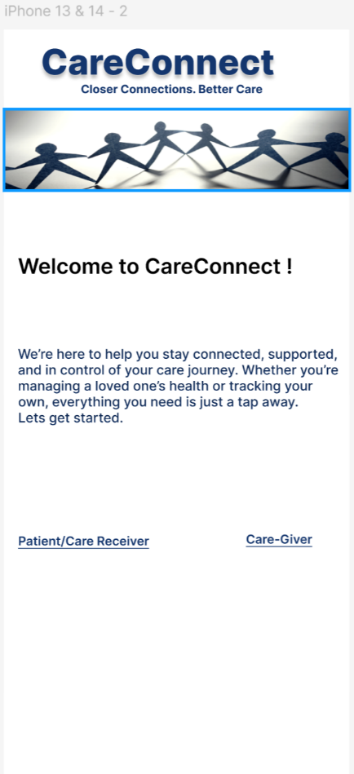

### Login Screen

Figure 2 represents the CareConnect login screen.

**Figure 2**

*CareConnect Login Screen*

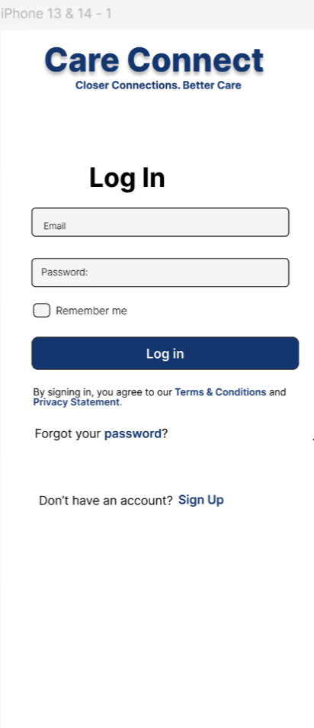

### Password Reset Screen

Figure 3 represents the CareConnect password reset screen.

**Figure 3**

*CareConnect Password Reset Screen*

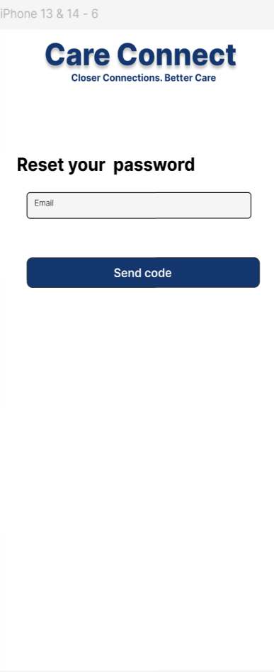

### Registration Screen

Figure 4 represents the CareConnect registration screen.

**Figure 4**

*CareConnect Registration Screen*

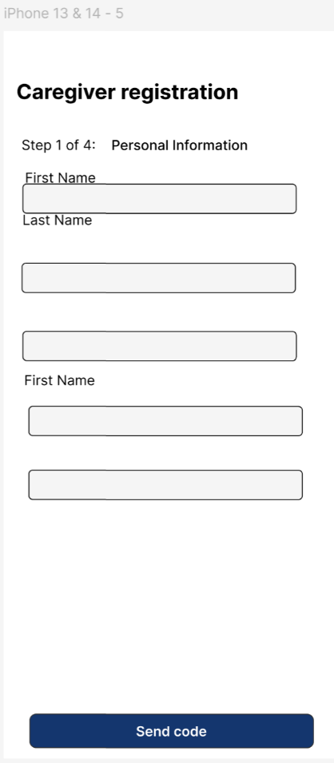

### Gamification Screen

Figure 5 represents the CareConnect gamification screen.

**Figure 5**

*CareConnect Gamification Screen*

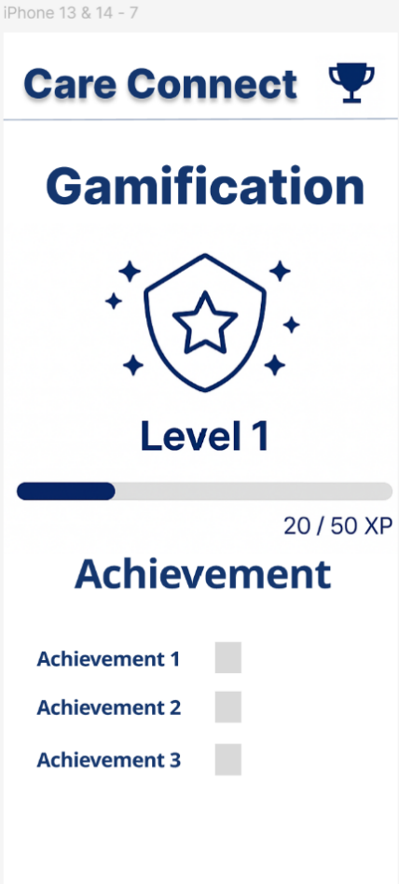

## Hardware Interfaces

All hardware endpoints use HTTPS/TLS v1.3 to reach CareConnect’s API Gateway; no direct LAN ingress. Amazon API Gateway (REST + WebSocket) acts as the primary interface between the client and backend microservices. It handles request routing, authorization, and load distribution.

Table 4 provides the hardware interfaces used with CareConnect.

**Table 4**

*CareConnect Hardware Interfaces*

|  |  |  |  |
| --- | --- | --- | --- |
| Subsystem | Device / Protocol | Direction | Notes |
| Mobile Client | iOS 15+/Android 11+ (ARM64), camera, microphone | Bidirectional | Captures audio/video for WebRTC; accesses device camera for QR onboarding. |
| Wearables | Fitbit Sense 2 / Versa 4 via Fitbit Web API | Inbound | Syncs heart-rate, steps, SpO₂; OAuth 2.0 authorization on device first. |
| Smart Cameras | Nest Cam (Google), Ring Cam, generic RTSP (H.264) | Inbound | Streams events (motion, fall detection). RTSP endpoints require on-premise gateway. |
| Security Keys (optional) | FIDO2/U2F over USB or NFC | Bidirectional | For caregivers opting into hardware MFA. |

## Software Interfaces

Table 5 provides the software interfaces used with CareConnect.

**Table 5**

*CareConnect Software Interfaces*

|  |  |  |  |
| --- | --- | --- | --- |
| Interface | Type & Protocol | Purpose | Key Requirements |
| Stripe | REST/HTTPS, Webhooks | Payment processing | PCI-DSS SAQ-A; tokenization via Stripe Elements. |
| AWS Cognito | OAuth 2.0 / OIDC | Authentication | Supports Google, Apple, and email/password sign-ins. |
| APNs | HTTP v1 API | Push notifications | Android/iOS web push tokens stored in device_tokens table. |
| Fitbit Web API | REST/HTTPS | Wearable data ingestion | Scopes: activity, heartrate, spo2. OAuth refresh every 8 h. |
| Google Nest API | REST/HTTPS + WebRTC (ICE/STUN/TURN) | Smart-camera event stream | Requires Google OAuth; events forwarded to device_metrics. |
| LLM Gateway | REST/HTTPS | AI assistant queries | Presently OpenAI API; 8 k token limit and <2 s response expectation. |
| AWS S3 | HTTPS (signed URL) | Media storage (images/videos/PDFs) | Pre-signed PUT URLs, server-side encryption (SSE-KMS). |
| AWS EventBridge | JSON events | Batch job scheduling | Nightly aggregation for analytics. |

## Communications Interface

All traffic is forced to HTTPS; HSTS header enabled. Table 6 provides the communications interfaces used with CareConnect.

**Table 6**

*CareConnect Communications Interfaces*

|  |  |  |  |  |
| --- | --- | --- | --- | --- |
| Channel | Protocol | Port(s) | Encryption | Use |
| Public API Gateway | REST / JSON | 443 | TLS 1.3 | All client–server CRUD and auth calls. |
| Real-time updates | WebSocket | 443 | WSS/TLS 1.3 | Live dashboard metrics. |
| WebRTC Media | DTLS-SRTP | UDP : 1024-65535 | End-to-end via TURN | Audio/video calls between users. |
| Stripe Webhook | HTTPS POST | 443 | TLS + sig | Payment and Billing status |
| AWS SNS → FCM/APNs | HTTPS | 443 | TLS 1.3 | Push notifications to mobile devices. |

## Operations

Table 7 specifies the CareConnect operations.

**Table 7**

*CareConnect Operations*

|  |  |
| --- | --- |
| Area | Requirement |
| Monitoring | Centralized logs in AWS CloudWatch; metrics exported to Prometheus; alerting via CloudWatch Alarms + SNS |
| Backup | Daily RDS snapshots; S3 versioning; 35-day retention. |
| Disaster Recovery | RDS Multi-AZ; S3 cross-region replication; infrastructure as code for redeploy in <4 h (RTO) |
| Maintenance | Zero-downtime deployments using ECS blue/green; rolling update of Flutter web on CloudFront. |
| Audit Logging | All auth, billing, and PHI access logged with user ID and IP; immutable storage via AWS Lake Formation. |

## Reporting Requirements

All reports generated via AWS Lambda; PDF built with files expire after 30 days. Table 8 provides the reporting requirements for CareConnect.

**Table 8**

*CareConnect Reporting Requirements*

|  |  |  |  |
| --- | --- | --- | --- |
| Report | Audience | Format | Frequency / Trigger |
| Adherence Dashboard PDF | Caregiver | PDF | On-demand (monthly default range) |
| Raw Logs Export | Caregiver | CSV | On-demand for chosen date range |
| Billing Status Report | Finance Team | CSV | Nightly batch, S3 drop |
| Audit Trail Extract | Compliance | JSON | Weekly; pushed to secure bucket for SOC2/HIPAA review |

## Site Adaptation

Environment flags managed via AWS SSM Parameter Store; Flutter reads at build time. Table 9 lists the site adaptation.

**Table 9**

*CareConnect Site Adaptation*

|  |  |  |
| --- | --- | --- |
| Environment | Target | Adaptation actions |
| Development | us-east-1 sandbox VPC | Use smaller RDS db.t3.micro; Stripe test keys. |
| Staging | us-east-1 isolated VPC | Mirror production infra; test keys; whitelisted client IPs. |
| Production | us-east-1 + backup in us-west-2 | Enable autoscaling; MSK multi-AZ; Cloud Map rules; HIPAA logs enabled. |

## Business Rules

Table 10 provides the business rules for CareConnect.

**Table 10**

|  |  |
| --- | --- |
| *CareConnect Business Rules*Rule ID | Business rule |
| BR-1 | A patient must maintain an **ACTIVE** subscription to add more than one care giver. |
| BR-2 | Each patient is billed **immediately** at sign-up; subsequent charges recur monthly at 00:00 UTC. |
| BR-3 | If a subscription enters **SUSPENDED** status, new calls cannot be initiated, but existing patient data remain view-only. |
| BR-4 | PHI must be stored only in HIPAA-eligible AWS services and encrypted with KMS-managed keys (AES-256). |
| BR-5 | Wearable data older than **365 days** is automatically archived to S3 Glacier; retrieval requires admin approval. |
| BR-6 | A notification is considered delivered when FCM/APNs returns a success response; retries follow exponential back-off. |
| BR-7 | PDF and CSV exports may only be generated by caregivers with the role **PRIMARY**; delegates require explicit permission. |

# System Features/Modules

## Onboarding & Authentication

### Welcome Screen

**5.1.1.1 Description/Priority**

The welcome screen is the first point of interaction for new users (patients and caregivers) launching the CareConnect app. It introduces the platform with a warm greeting and provides direct access to important documents like the Terms & Conditions and Privacy Policy. This screen is shown only during the first app launch.

**5.1.1.2 Stimulus/Response Sequences**

**Stimulus:** User opens the app for the first time.  
**Response**: The app displays a welcome message, links to Terms & Conditions and Privacy Policy (modal popups), and a “Next” button.

**Stimulus**: User taps the “Next” button.  
**Response**: App transitions to the Account Creation screen.

**Stimulus**: Returning user launches the app again.  
**Response**: App bypasses the welcome screen and loads the dashboard if a session exists.

**5.1.1.3 Functional Requirements**

**REQ-5.1.1.1:** The system shall display a welcome screen with a warm message upon the first launch.

**REQ-5.1.1.2:** The system shall provide modal popups with scrollable text for Terms & Conditions and Privacy Policy.

**REQ-5.1.1.3:** The system shall display a “Next” button to proceed to registration.

**REQ-5.1.1.4:** The system shall store the user’s first-time launch status locally to prevent showing the welcome screen again.

**REQ-5.1.1.5:** The system shall automatically bypass the welcome screen on subsequent launches if the user has already completed it.

#### 5.1.1.4 Sequence Diagram

Figure 6 depicts the welcome screen sequence diagram.

**Figure 6**

*Welcome Screen Sequence Diagram*

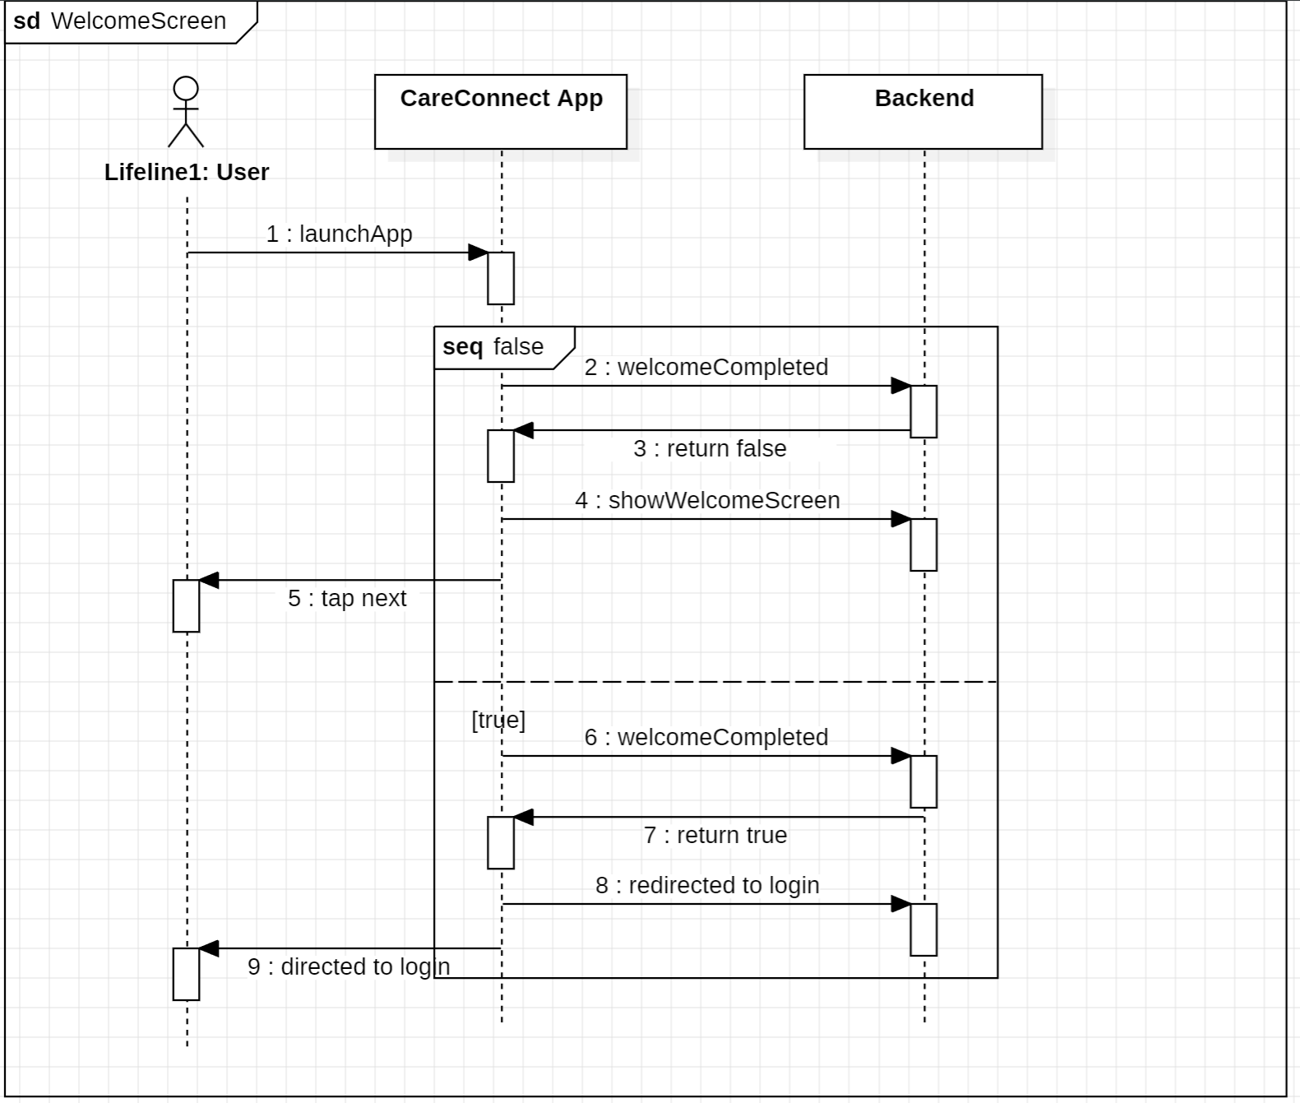

### User Registration (email/password, SSO, SMS-OTP)

*5.1.2.1 Description*

The system should allow users to register for an account using one of the following methods: Email and password combination, by verifying a phone number with an SMS one-time password (OTP), or by using Single Sign-On (SSO) via a provider like Google.

* \This feature provides flexible and secure onboarding options and integrates with industry-standard authentication systems. It supports account uniqueness, access control, and user identity verification.

#### 5.1.2.2 Stimulus/Response Sequences

Table 11 provides the user registration stimulus/response sequences.

**Table 11**

*User Registration Stimulus/Response Sequences*

|  |  |
| --- | --- |
| Stimulus | System response |
| User submits valid email and password in registration form | System creates a user account, stores hashed password, and sends a confirmation email |
| User submits email in an invalid format | System displays an error message: “Invalid email format” |
| User attempts to register with an already registered email | System displays an error message: “Email already in use” |
| User clicks "Register with Google" | System redirects to Google’s OAuth2 login page |
| User successfully authenticates via Google | System creates account using Google profile data and logs the user in |
| User enters valid phone number for OTP | System sends a time-limited OTP via SMS |
| User submits correct OTP within time limit | System completes registration and logs the user in |
| User submits expired or incorrect OTP | System displays error message: “Invalid or expired code” and allows retry |
| User attempts to register while offline | System displays a connectivity error and prevents submission until connection is restored |

#### 5.1.2.3 User Requirements

* FR-3.1.1 The system shall provide a registration form with fields for email and password.
* FR-3.1.2 The system shall validate the format of the entered email address and enforce password complexity rules.
* FR-3.1.3 The system shall hash and store the user's password securely using a cryptographic hashing algorithm.
* FR-3.1.4 The system shall provide options to register via third-party SSO providers such as Google and Microsoft.
* FR-3.1.5 The system shall authenticate SSO credentials via the respective provider’s OAuth2 flow.
* FR-3.1.6 The system shall allow registration using a mobile phone number and shall send a time-limited OTP via SMS.
* FR-3.1.7 The system shall validate the OTP before completing the registration process.
* FR-3.1.8 The system shall prevent duplicate account creation using the same email address or phone number.
* FR-3.1.9 The system shall log all registration attempts for auditing and security purposes.
* FR-3.1.10 The system shall notify the user of successful registration via email or SMS.

#### 5.1.2.4 Use Case Diagram

Figure 7 depicts the user registration use case diagram for CareConnect

**Figure 7**

*User Registration Use Case Diagram*

#### 5.1.2.5 Sequence Diagram

Figure 8 depicts the user registration sequence diagram for CareConnect

**Figure 8**

*User Registration Sequence Diagram*

### Login/Logout Flows (session persistence, timeout rules)

#### 5.1.3.1 Description

The system should provide secure user login and logout functionality. Users must be able to log in using either email and password or third-party Single Sign-On (SSO) providers, such as Google or Microsoft. Sessions will persist across browser tabs and will expire after a period of inactivity or a set time limit. When the user logs out, the session must be fully terminated to protect user data.

#### 5.1.3.2 Stimulus/Response Sequences

Table 12 provides the login/logout stimulus/response sequences.

**Table 12**

*Login/Logout Stimulus/Response Sequences*

|  |  |
| --- | --- |
| Stimulus | System response |
| User enters correct email and password and clicks "Login" | System verifies credentials, creates a session, and redirects the user to their dashboard |
| User enters incorrect login credentials | System displays an error message: “Incorrect email or password” |
| User selects "Login with Google" | System opens a login window for Google; upon success, creates or links the user account and logs them in |
| User is inactive for too long | System automatically logs the user out and shows a message: “You have been logged out due to inactivity” |
| Session reaches maximum time limit | System ends the session and asks the user to log in again |
| User clicks "Logout" | System ends the session, removes any session data or cookies, and redirects the user to the homepage |
| User refreshes the page while still logged in | System maintains the session and keeps the user logged in |

#### 5.1.3.3 Functional Requirements

* FR-3.2.1 The system shall allow users to log in using their email and password.
* FR-3.2.2 The system shall allow users to log in using supported third-party SSO providers (e.g., Google, Microsoft).
* FR-3.2.3 The system shall start a user session upon successful login and keep the session active across browser tabs.
* FR-3.2.4 The system shall log out users automatically after a configurable period of inactivity (idle timeout).
* FR-3.2.5 The system shall log out users after a maximum session duration (absolute timeout), even if the user is active.
* FR-3.2.6 The system shall fully log out users when they click the "Logout" button, including clearing session data and cookies.
* FR-3.2.7 The system shall redirect users to the login page if they try to access secure pages after logout or timeout.
* FR-3.2.8 The system shall record login and logout events for security logging.

#### 5.1.3.4 Use Case Diagram

Figure 9 depicts the login/logout use case diagram for CareConnect.

**Figure 9**

*Login/Logout Use Case Diagram*

#### 5.1.3.5 Sequence Diagram

Figure 10 depicts the login/logout sequence diagram for CareConnect.

**Figure 10**

*Login/Logout Sequence Diagram*

### Password Reset & Account Recovery Caregiver

**Caregiver**

5.1.4.1 Description & Priority

Priority Medium: When a caregiver needs to reset their password or recover their account, the application shall allow this. This is done the same way for both (Password Reset & Account Recovery).

5.1.4.2 Stimulus/Response Sequence

Stimulus: The caregiver shall click on “forgot password/account recovery” on the home page.

Response: The application goes to a page where the caregiver shall answer one of their 3 privacy questions when registering.

Stimulus: The caregiver answers a security question correctly and presses “submit”.

Response: The application verifies that the answer is correct and brings them to a screen where they have to enter a new password.

Stimulus: The caregiver creates a new password, types it in twice and clicks “submit”.

Response: The application verifies that the password is typed correctly twice and resets the password and account.

5.1.4.3 Functional Requirements

REQ- 5.1.4.3.1: The application shall email the caregiver that their password has been changed.

REQ- 5.1.4.3.2: The application shall not let the caregiver have the same password as previously.

REQ- 5.1.4.3.3: The application shall not accept a password that was not entered correctly twice.

REQ- 5.1.4.3.4: The application shall allow the caregiver to change their password only two times in a week

**Patient**

5.1.4.4 Description & Priority

Priority Medium: When a patient needs to reset their password or recover their account, the application shall allow this. This is done the same way for both (Password Reset & Account Recovery).

5.1.4.5 Stimulus/Response Sequence

Stimulus: The patient shall click on “forgot password/account recovery” on the home page.

Response: The application goes to a page where the patient shall input their date of birth and address.

Stimulus: The patient answers the questions correctly and presses “submit”.

Response: The application verifies that the answers are correct and brings them to a screen where they have to enter a new password.

Stimulus: The patient creates a new password, types it in twice and clicks “submit”.

Response: The application verifies that the password is typed correctly twice and resets the password and account.

5.1.4.6 Functional Requirements

REQ- 5.1.4.6.1: The application shall email the patient that their password has been changed.

REQ- 5.1.4.6.2: The application shall not let the patient have the same password as previously.

REQ- 5.1.4.6.3: The application shall not accept a password that was not entered correctly twice.

REQ- 5.1.4.6.4: The application shall allow the patient to change their password indefinitely.

## Billing & Subscription Management

This section details each billing sub-feature listed under SF-2, with requirements, priorities, dependencies, and acceptance criteria. Based on serverless constraints and timeline, CareConnect implements up-front billing without trials or promo codes; basic payment methods (credit card, PayPal) via Stripe; and failure handling via automatic suspension, downgrade, and grace period. Email-based payment reminders and complex promotions are deferred.

### Plan Definitions & Pricing Tiers

**FR-B1**: **Plan Catalog**

* + *Description:* System shall present two plans—**Standard** at $20/patient/month and **Premium** at $30/patient/month—during signup.
  + *Priority:* High
  + *Dependencies:* SF-2, payment UI component (Section 6.1).
  + *Acceptance Criteria:* Plans display correctly; pricing updates after backend configuration.

**Stimulus/Response**

Stimulus: *Patient* selects a plan on the pricing screen

Response: Present Stripe Elements, request payment token, and lock UI until tokenization completes

### Subscription Activation (trigger on signup vs. first patient)

**FR-B2**: **Immediate Activation**

* + *Description:* Upon successful payment at signup, activate the subscription immediately—no trial period.
  + *Priority:* High
  + *Dependencies:* FR-B1, Payment Methods & Fail-over (7.2.3).
  + *Acceptance Criteria:* New accounts with payment receive “ACTIVE” status in billing_subscriptions table.

**Stimulus/Response**

Stimulus: Stripe returns a valid payment token

Response: Create an ACTIVE subscription record and charge the card

### Payment Methods & Fail-over (credit card, PayPal)

**FR-B3**: **Primary & Backup Methods**

* + *Description:* Support credit-card and PayPal through Stripe; if credit-card charge fails, automatically retry and then switch to PayPal if configured.
  + *Priority:* Medium
  + *Dependencies:* Stripe integration module; user profile payment settings.
  + *Acceptance Criteria:* Simulated card failure triggers up to 3 retries, then a PayPal redirect; logs reflect each attempt.

**Stimulus/Response**

Stimulus: Stripe returns *payment failed* on initial charge

Response: Enqueue a retry job with exponential back-off (1 h → 4 h → 24 h) and push a “payment retrying” notice

### Billing Failure Handling (suspend, downgrade, grace period)

**FR-B4**: **Grace Period & Downgrade**

* + *Description:* On continuous payment failures for 5 days, suspend the subscription and move the subscription to a **Basic** read-only tier for an additional 3-day grace period before complete deactivation.
  + *Priority:* Medium
  + *Dependencies:* Notification service (SF-4), user status management.
  + *Acceptance Criteria:* Billing failures increment a counter; suspension and downgrade flags set per schedule; patient receives push notifications on each status change.

**Stimulus/Response**

Stimulus: The third retry also fails

Response: Change subscription status to SUSPENDED, start 3-day grace timer, push suspension notice

5.2.5 Stripe Integration

**FR-B5**: **Secure Tokenization**

* + *Description:* All payment details must be tokenized via Stripe Elements on the client; no raw card data stored on CareConnect servers.
  + *Priority:* High
  + *Dependencies:* Frontend payment form (Flutter), backend billing-service endpoints.

*Acceptance Criteria:* Stripe tokens created and exchanged; audit log contains only token IDs.

**Stimulus/Response**

Stimulus: Patient taps “Pay” on the Flutter payment form after entering card details.

Response:

1. Front-end invokes Stripe Elements createToken; UI shows spinner (≤ 500 ms).
2. Stripe returns a token; Flutter posts the token (not card data) to POST /subscriptions.
3. Back-end logs token ID only, invokes charge flow, and returns success/failure to client (< 2 s round-trip).

Figure 10 depicts patient interactions with the billing module.

**Figure 10**

*Patient Interactions with Billing Module*

1. 5.2‑1**View Plans:** Patient views and selects between Standard and Premium.
2. **Enter Payment Method:** Payment details are collected and tokenized securely.
3. **Activate Subscription:** Subscription status transitions to ACTIVE on payment success.
4. **Handle Payment Failure:** System retries, then suspends/downgrades on continued failure, notifying patient.
5. **View Billing Status:** Patient may view current subscription status at any time.

Figure 11 depicts the patient subscription billing flow.

**Figure 11**

*Patient Subscription Billing Flow.*

5.2‑2

## User & Role Management

### Caregiver Profiles (professional vs. family)

**Description:**  
 The system includes two predefined roles for a caregiver: professional and family caregivers. Both types of caregivers can link to patients, assign tasks to patients, and track patient vitals.

**Functional Requirements:**

* **REQ-5.3.1.1:** The system shall provide caregivers with access to a list of all patients within the application.  
   *Priority: High*
* **REQ-5.3.1.2:** Caregivers shall have the option to link specific patients to provide care for them.

*Priority: High*

* **REQ-5.3.1.3:** Caregivers shall have the option to assign tasks to their patients.  
   *Priority: High*
* **REQ-5.3.1.4:** Caregivers shall have the ability to monitor patient vitals.  
   *Priority: High*

### Patient Profile

**Description:**  
The system shall provide a predefined role for patients, granting them access to features that support their personal health management. Patients can view and update their personal information, monitor assigned tasks, track their vital signs, and communicate with their caregivers. Patients can view, complete, and mark tasks with timestamps. Task data is stored and managed via backend microservices and Amazon RDSThis role ensures that patients have the necessary tools to engage actively in their healthcare journey while maintaining data privacy and security.Push notifications can be enabled for scheduled tasks via FCM/APNs

**Functional Requirements:**

* **REQ-5.3.2.1**: The system shall allow patients to view and edit their personal information, including contact details and medical history.

*Priority*: High

* **REQ-5.3.2.2**: The system shall enable patients to view a list of tasks assigned to them by caregivers.

*Priority*: High

* **REQ-5.3.2.3**: The system shall allow patients to record and track their vital signs, such as blood pressure and heart rate.

*Priority*: High

* **REQ-5.3.2.4**: The system shall provide a messaging interface for patients to communicate with their linked caregivers.

*Priority*: Medium

* **REQ-5.3.2.5**: The system shall restrict patients from accessing administrative or caregiver-specific functionalities.

*Priority*: High

* **REQ-5.3.2.6**: The system shall log all patient interactions for auditing and monitoring purposes.

*Priority*: Medium

### Multi-Caregiver Support

**Description:**  
In many cases, it is necessary to assign multiple caregivers to one patient to allow for full coverage of the patient’s healthcare. This could be due to the patient’s condition or disease requiring more than one caregiver to support them. The caregiver has the ability to add or invite the patient after the patient has already been linked to another caregiver. Each patient that the caregiver supports shall be listed on their Caregiver Dashboard list of patients. Each caregiver that the patient is linked to shall appear on their Patient Dashboard list of caregivers.

**Functional Requirements:**

* **REQ-5.3.3.1:** The system shall allow multiple caregivers to link to the same patient.  
   *Priority: High*
* **REQ-5.3.3.2:** Patients shall receive tasks from multiple caregivers at the same time.

*Priority: High*

### Patient Profiles & Linking (invite, QR code, approval)

**Description:**  
A patient’s profile will be linked to a caregiver’s profile via two different methods: scanning a QR Code of a different user’s account ID in their profile settings, or by sending a specific user an invite to link to them. This will link directly to a caregiver, allowing them to provide care for the requested patient.

**Functional Requirements:**

* **REQ-5.3.4.1:** The system shall generate a unique QR Code for each caregiver’s profile.  
   *Priority: High*
* **REQ-5.3.4.2:** The system shall take input from a caregiver’s uniquely generated QR Code and link a patient’s profile to the caregiver’s profile.  
   *Priority: High*

#### Use Case Diagram

Figure 12 depicts the patient profiles and linking use case diagram.

**Figure 12**

*Patient Profiles and Linking Use Case Diagram*

#### Sequence Diagram

Figure 13 depicts the patient profiles and linking sequence diagram.

**Figure 13**

*Patient Profiles and Linking Sequence Diagram*

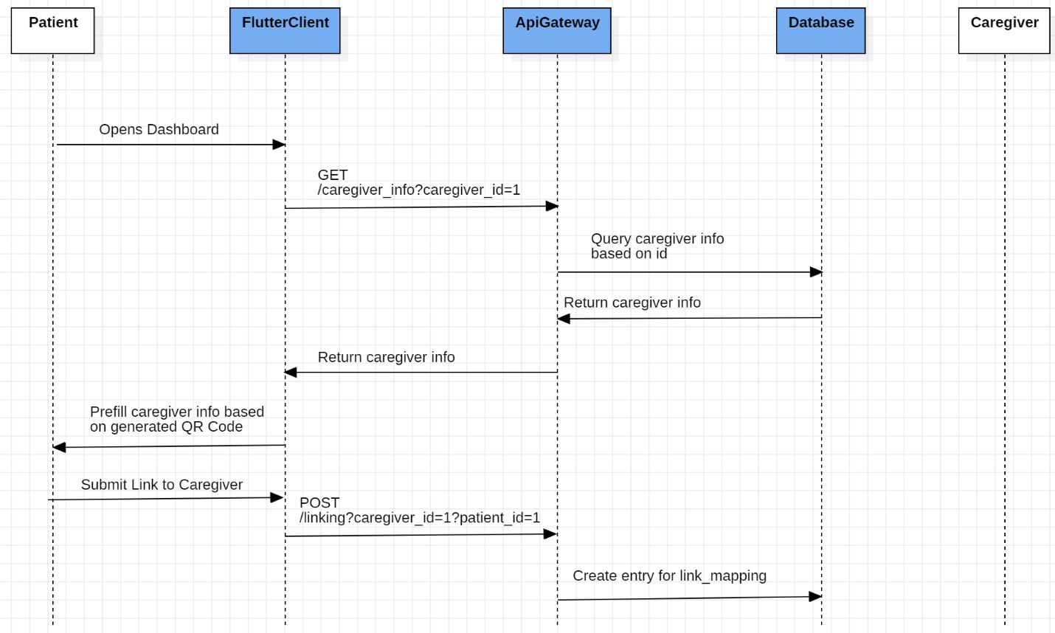

### Access Control & Permissions

**Description:**  
Due to CareConnect’s role-specific features, some features will not be accessible to users based on their role. Patients will not be able to view caregiver-related tasks or screens. Caregivers will not be able to link themselves to other caregivers.

**Functional Requirements:**

* **REQ-5.3.5.1:** The system shall only allow users with the role of caregiver or higher to view the full list of patients.  
   *Priority: Medium*
* **REQ-5.3.5.2:** The system shall only allow users with the role of caregiver or higher to assign tasks to their linked patients.  
   *Priority: Medium*
* **REQ-5.3.5.3:** The system shall only allow users with the role of caregiver or higher to monitor the vitals of their linked patients.  
   *Priority: Medium*

#### Use Case Diagram

Figure 14 depicts the access controls and permissions use case diagram.

**Figure 14**

*Access Controls and Permissions Use Case Diagram*

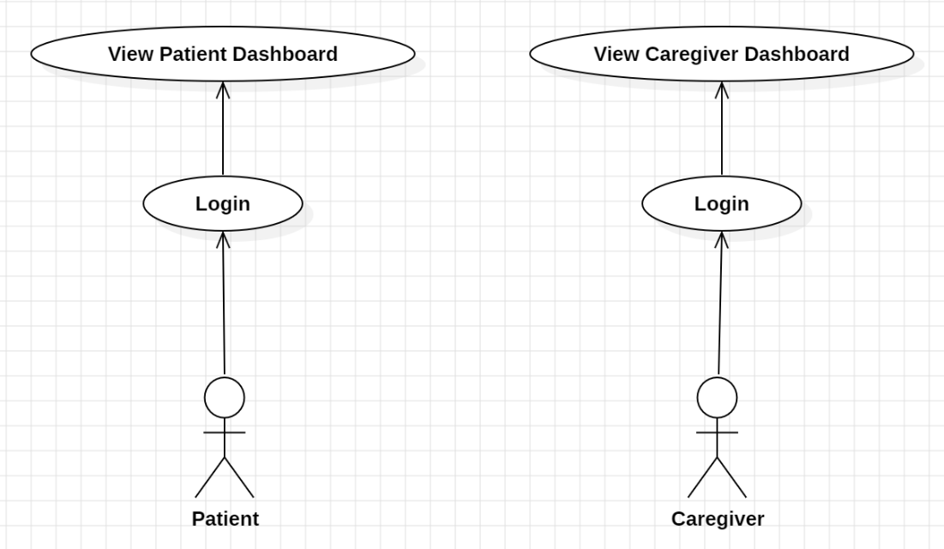

### Family Read only Access

**Priority:** Medium

**Dependencies:** Patient and caregivers must be registered in the system. Data access control modules are required.

**Acceptance Criteria:**

* Caregivers can invite and configure access for a family member.
* Family members can view only authorized data.
* Family members cannot edit, delete, or add data.

**Functional Requirements:**

FR 5.3.6.1: The system shall allow caregivers to invite family members with “read-only” access to specific patient data.

FR 5.3.6.2: The system shall allow caregivers to customize their views (data).

FR 5.3.6.3: The system shall allow patients to revoke family member access at any time.

FR 5.3.6.4: The system shall restrict family members from editing, deleting, or adding data.

Stimulus/Response

Table 13 provides the family read-only access stimulus/response sequences.

**Table 13**

*Family Read-Only Access Stimulus/Response Sequences*

|  |  |
| --- | --- |
| Stimulus | System response |
| Caregiver sends an invite to a family member | System sends email/SMS |
| Family members access the dashboard | Only permitted data is displayed |
| Patient revokes access | System notifies Family member and access is removed |

#### Use Case Diagram

Actors:

* Caregiver
* Family Members (Read-only User)
* Patient (Optional: Can remove access)

Figure 15 depicts the family read only access use case diagram.

**Figure 15**

*Family Read Only Access Use Case Diagram*

### Add Existing Patient to Caregiver Dashboard

5.3.7.1 Description & Priority

This feature shall allow the Caregiver to search for existing patients with an email address. After entering an email address, the system shall check the patient records for any patients with a matching email address. If an existing email address is found, the system shall notify the caregiver of an existing patient and ask the caregiver if they shall send an email request to the patient for adding the patient to the caregiver’s dashboard. If an existing patient record does not exist, the system shall notify the caregiver and direct the caregiver to the register a new patient flow. Priority = High.

5.3.7.2 Stimulus/Sequence Response:

Stimulus: The caregiver shall select the ‘Register Patient’ button

Reesponse: The system directs the caregiver to the patient search screen.

Stimulus: The system requests the caregiver to enter the patient’s email address.

Response: The caregiver enters the patient’s email address.

Stimulus: The caregiver selects the ‘Search’ button.

Response: The system searches the patient records for an existing email address.

Stimulus: The system finds a matching email.

Response: The system returns a match.

Stimulus: The system does not find a matching email.

Response: The system returns no matches.

Stimulus: The caregiver receives no match notification.

Response: The caregiver moves to the register new patient flow.

Stimulus: The caregiver receives a match notification.

Response: The caregiver views the match notification.

Stimulus: The caregiver selects the ‘Send Email Request’ button.

Response: The system sends an email of the request to the patient.

Stimulus: The patient receives the email.

Response: The patient views the email.

Stimulus: The patient accepts the request.

Response: The system receives the acceptance response.

Stimulus: The system processes the acceptance response.

Response: The system adds the patient to the caregiver’s dashboard.

5.3.7.3 Functional Requirements

REQ-5.3.7.3.1: The caregiver shall search for patients when triggering the register patient flow.

REQ-5.3.7.3.2: The system shall perform a search for matching email addresses in the patient records and notify the caregiver if there is a matching patient record with the given email address.

REQ-5.3.7.3.3: The system shall notify the caregiver if there is no patient record match and direct the caregiver to the register new patient flow.

REQ-5.3.7.3.4: The system shall send an email request to the patient’s email if the caregiver decides to send a request to the patient.

REQ-5.3.7.3.5: The system shall process the acceptance or rejection if the patient receives the email and decides to accept or reject the request.

REQ-5.3.7.3.6: The system shall notify the caregiver of the patient’s decision after receiving the patient response in the email.

Use Case Diagram

**Figure 15**

*Add Existing Patient to Caregiver Dashboard Use Case Diagram*

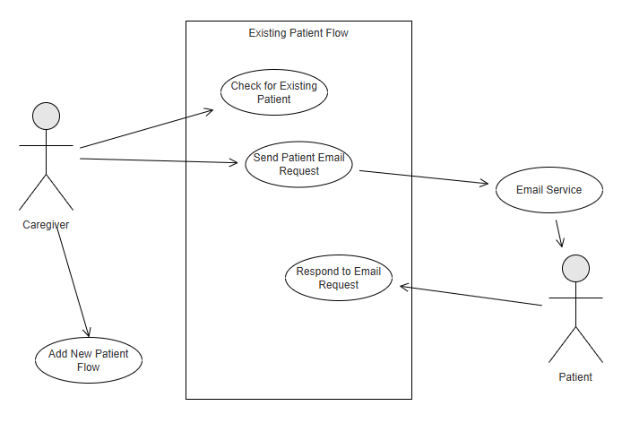

## Dashboards

### Patient Dashboard (Caregiver View)

Description- The Patient Dashboard (Caregiver View) serves as the main interface for caregivers, offering a comprehensive and interactive environment to monitor, manage, and communicate with their patients. It presents an at-a-glance overview of patient information along with quick-access menus for streamlined care coordination.

**Priority**: High

**Dependencies:** Requires linked caregiver and patient profiles, scheduling and communication modules.

**Acceptance Criteria**:

* Dashboard loads upon caregiver login.
* Displays patient names and thumbnails.
* “+” button icon to add new Patients.
* Each patient card includes access to view, edit, and archive a patient.

**Function Requirement**

FR 5.4.1: The system shall display a list of linked patients for a caregiver.

FR 5.4.2: The system shall display Patient’s Name, profile thumbnail (if available).

FR 5.4.3: The system shall include a floating action button (“+”) to add new Patients.

FR 5.4.4: Each patient card shall include icons to view Profile, Edit Information and Archive Patient.

FR 5.4.5: The dashboard shall be updated in real time.

Table 14 provides the patient dashboard (caregiver view) stimulus/response sequences.

**Table 14**

*Patient Dashboard (Caregiver View) Stimulus/Response Sequences*

|  |  |
| --- | --- |
| Stimulus | System response |
| Caregiver logs in | System displays patient dashboard |
| Caregiver clicks “+” (Add Patient) | System opens a form for adding new patient |
| Caregiver edits patient information | System updates the new patient |
| Caregiver archives a patient | System moves a patient to an archived list |

#### Use Case Diagram

Figure 16 depicts the caregiver view use case diagram.

**Figure 16**

*Caregiver View Use Case Diagram*

**5.4.3.1 Patient dashboard action menu icons (for caregiver to use)**

### Description & Priority

**Priority: Medium**  
 The patient dashboard action menu icons allow caregivers to click on different actions to be redirected to corresponding pages or functionalities.

5.4.3.2 Stimulus/Response Sequence Stimulus: Caregiver clicks on the "Details" icon in the patient dashboard.  
 Response: Redirects to patient profile page displaying demographics and medical conditions.

Stimulus: Caregiver clicks on the "Edit" icon.  
 Response: Redirects to a form interface allowing modification of patient info, media, and allergies.

Stimulus: Caregiver selects "Archive" icon.  
 Response: Prompts a confirmation dialog, and upon confirmation, moves the patient to the inactive list.

Stimulus: Caregiver selects "Care Schedules" icon.  
 Response: Displays an interface to manage schedules with templates and custom tasks, and options for allergies, medications, meals, exercise, and notifications.

Stimulus: Caregiver accesses "Communication Settings."  
 Response: Provides options to configure Unavailable Mode, record or upload audio/video messages, and create call invites.

Stimulus: Caregiver initiates an audio/video call with the patient.  
 Response: The call connects directly without ringing. Caregiver can interact immediately and use emotion detection via the heart button.

Stimulus: Caregiver clicks on "Healthcare Notes."  
 Response: Displays sections for doctor call transcripts, uploads, scans, and allows tagging by specialty.

Stimulus: Caregiver activates "Ask (AI Assistant for Healthcare)."  
 Response: Returns an actionable answer in text/audio, links to relevant healthcare notes, and provides a disclaimer with an option to contact the healthcare provider

5.4.3.3 Functional Requirements

**REQ-5.4.3.3.1:**  
 The system shall display clearly visible and accessible action menu icons for caregiver use on the patient dashboard.

**REQ-5.4.3.3.2:**  
 The system shall ensure that each icon redirects to its respective functionality page within 2 seconds of activation.

**REQ-5.4.3.3.3:**  
 The system shall support the creation and customization of care schedules using both predefined templates and user-defined tasks, including attributes for allergies, medications, meals, exercise routines, and caregiver/patient notifications.

**REQ-5.4.3.3.4:**  
 The action menu shall include the following core functionalities:

**Details:**

Display the patient’s demographic and medical condition data.

**Edit:**

Allow modifications to patient information, uploaded media, and allergy records.

**Archive:**

Enable the caregiver to archive a patient record with confirmation via dialog.

**Care Schedules:**

**Pre-built templates:** Auto-generate care routines.

**Custom tasks:** E.g., "Physical Therapy at 3 PM".

**Notifications:** Set alerts for both caregiver and patient.

**Communication Settings:**

**Unavailable Mode:** Set automatic replies via custom text or recorded audio/video.

**Call Invites:** Create tappable video messages to prompt a callback.

**Audio/Video Calling:**

Initiate direct in-app calling with no ringing or number exposure.

Emotion detection enabled via heart button (on-device processing).

In-call features: camera toggle, mute, rear camera, and multi-user join.

**Healthcare Notes:**

Provide categorized documentation including:

Transcripts of doctor calls (manual and voice-to-text).

Uploaded PDFs and images.

Scans via device camera.

Specialty tagging (e.g., "Cardiology").

**Ask (AI Assistant for Healthcare):**

**Input:** Accept text or voice questions.

**Output:** Provide answers with links to related notes.

**Disclaimer:** Warn to verify with a provider and offer to initiate a call if needed.

**5.4.4.1Caregiver dashboard action menu icons (for patient to use)**

### Description & Priority

**Priority: Medium**  
 The caregiver dashboard action menu icons allow patients to click on different actions to be redirected to the corresponding pages or trigger essential functionalities.

**5.4.4.2 Stimulus/Response Sequence**

**Stimulus:** Patient clicks on the **Call** icon.  
**Response:** Initiates an in-app voice or video call with the caregiver. The call connects immediately without ringing, allowing the patient and caregiver to communicate instantly. No personal phone number is displayed.

**Stimulus:** Patient selects the **Message** icon.

**Response:** Opens a messaging interface where the patient can send text, voice, or video messages. If the caregiver is unavailable, the message is stored and delivered when it becomes available.

**Stimulus:** Patient clicks the **Details** icon.  
 **Response:** Displays the caregiver's profile, shows their contact information, and assigned caregiving tasks.

**Stimulus:** Patient selects the **Edit/Remove** icon.  
 **Response:** Prompts a confirmation dialog. Upon confirmation, the caregiver's access is revoked from the patient's dashboard.

5.4.4.3 Functional Requirements

**REQ-5.4.4.3.1:**  
 The system shall display clearly labeled and accessible action menu icons (Call, Message, Details, Edit/Remove) on the caregiver dashboard for patient use.

**REQ-5.4.4.3.2:**  
 The system shall ensure all icon-triggered actions respond within 2 seconds and navigate or execute functions without requiring full page reloads.

**REQ-5.4.4.3.3:**  
 The system shall store any text, voice, or video message sent by the patient if the caregiver is unavailable and confirm delivery when the caregiver views the message.

**REQ-5.4.4.3.4:**

**Call Functionality:**

The system shall allow the patient to initiate a voice or video call to the caregiver directly within the app.

The system shall connect the call immediately without ringing and without exposing phone numbers.

**Message Functionality:**

The system shall allow the sending of text, voice, and video messages.

Messages shall be stored if the caregiver is unavailable and delivered when possible.

**Details View:**

The system shall display the caregiver’s profile information, including contact details and task assignments. Caregivers can assign and schedule daily health task (e.g., medication, exercise)

**Edit/Remove Functionality:**

The system shall allow the patient to remove the caregiver from their dashboard.

The system shall prompt a confirmation dialog before revoking caregiver's access to avoid accidental actions.

## Scheduling & Notifications

### Pre-defined Care Templates (medication, meals, exercise)

**Description:**  
 The system shall include a library of pre-defined care templates for common caregiving tasks such as medication schedules, meal planning, and exercise routines. These templates are intended to simplify and standardize caregiving tasks for both professional and family caregivers.

**Functional Requirements:**

* **REQ-5.5.1.1:** The system shall provide caregivers with access to pre-defined templates categorized under “Medication,” “Meals,” and “Exercise.”  
   *Priority: High*
* **REQ-5.5.1.2:** Each template shall include default time slots, task descriptions, and frequency settings (e.g., daily, weekly).  
   *Priority: Medium*
* **REQ-5.5.1.3:** Caregivers shall have the option to apply templates to a patient profile and modify the schedule as needed.  
   *Priority: High*
* **REQ-5.5.1.4:** The system shall allow caregivers to assign a start date and review the generated schedule for patient approval (if applicable).  
   *Priority: Medium*
* **REQ-5.5.1.5:** Once a template is assigned, it shall automatically generate scheduled tasks and reminders based on the selected frequency.  
   *Priority: High*

### Custom Task Scheduling (ad-hoc events)

**Description:**  
 In addition to pre-defined templates, the system shall allow caregivers to create custom or ad-hoc tasks for patients. This enables flexibility in accommodating unique or one-time caregiving needs. This feature enables caregivers to support patients in maintaining their health routines, including medication reminders and scheduled exercises. Each task can be customized with a specific title, schedule, frequency, and priority level. Tasks are managed in the backend and automatically synchronized across all connected devices for seamless access.

**Functional Requirements:**

* **REQ-5.5.2.1:** The system shall allow caregivers to create custom tasks by specifying the task name, description, date, time, and frequency.  
   *Priority: High*
* **REQ-5.5.2.2:** Custom tasks shall be assignable to individual caregivers or marked as shared among multiple caregivers.  
   *Priority: Medium*
* **REQ-5.5.2.3:** Each custom task shall trigger a push notification to the assigned caregiver and/or patient.  
   *Priority: High*
* **REQ-5.5.2.4:** The system shall allow editing and deletion of scheduled custom tasks with confirmation prompts.  
   *Priority: Medium*
* **REQ-5.5.2.5:** All custom tasks shall be displayed in the shared care calendar along with recurring templates.  
   *Priority: High*

### Notification Channels (push, email, SMS)

**Priority**: High

**Dependences:** Task scheduler, patient profile, caregiver communication settings

**Acceptance Criteria:**

* Caregiver can choose default channels per task type
* Patients can opt in/out of the channel.

**Functional Requirements**

FR 5.5.3.1: The system shall allow caregivers to configure preferred notification channels per task.

FR 5.5.3.2: The system shall send push notifications for scheduled care tasks.

FR 5.5.3.3: The system shall send SMS alerts for high-priority tasks.

FR 5.5.3.1: The system shall provide a notification history.

Stimulus/Response

Table 15 provides the Notification Channels stimulus/response sequences.

**Table 15**

*Notification Channels Stimulus/Response Sequences*

|  |  |
| --- | --- |
| Stimulus | System response |
| Caregiver schedules a task | System schedules notification based on preferred channel |
| Notification time is reached | System sends alerts |
| Patient marks task complete | System updates and stops sending reminders |
| Caregiver view notification log | System displays all completed task |

#### Use Case Diagram

Actors:

* + Caregiver
  + Patient

Figure 17 depicts the notification channels use case diagram.

**Figure 17**

*Notification Channels Use Case Diagram*

### Reminder & Alert Rules

The reminder and alert system cover various scenarios that will be further developed in the sections that follow.

#### 5.5.4.1 Patient-Oriented Scenarios

##### Patient scheduled reminders

REQ-5.4.4.1: Based upon the patient's scheduled medications and activities, the system shall generate a reminder via a push notification. Priority: High.

##### 5.5.4.1.2 Stimulus/Response Sequence

Stimulus: The system clock reaches a scheduled time for medication or activity.  
Response: The system sends a notification to the patient via push notification.

#### 5.5.4.2 Patient Marks Task as Completed

REQ-5.5.4.1.2: The system shall allow the patient to mark scheduled tasks and activities as complete. Priority: High.

REQ-5.5.4.1.2.1: Once the activity or scheduled tasks time has passed, the system shall log the patient's response and update the caregiver. Priority: High.

##### 5.5.4.2.1 Stimulus/Response Sequence

Stimulus: The patient interacts with the notification to mark a task as completed.  
Response: The system logs the task with a timestamp and updates the caregiver.

#### 5.5.4.1.3 Patient Misses a Task

REQ-5.5.4.1.3: The system shall flag a task as missed and generate an alert to the caregiver if and only if the patient missed marking the task as complete. Priority: High.

##### 5.5.4.1.3.1 Stimulus/Response Sequence

Stimulus: The patient fails to mark a task as completed within the specified time window.  
Response: The task is flagged as missed, and an alert is sent to the patient’s caregiver

#### 5.5.4.2 Caregiver-Oriented Scenarios

##### 5.5.4.2.1 Caregiver Receives Missed Task Alert

REQ-5.5.4.2.1: The system shall push a real time alert notification about a missed task to the caregiver if and only if one of their patient missed to mark a task as completed.

##### 5.5.4.2.1.1 Stimulus/Response Sequence

Stimulus: A patient misses a scheduled task.  
Response: The system pushes a real-time alert to the caregiver.

##### 5.5.4.2.2 Caregiver scheduled reminders

REQ-5.5.4.2.2: Based upon the caregiver's scheduled tasks and activities, the system shall generate a reminder via a push notification. Priority: High.

##### 5.5.4.1.2 Stimulus/Response Sequence

Stimulus: The system clock reaches a scheduled time for scheduled activities.  
Response: The system sends a notification to the caregiver via a push notification.

### Caregiver Shift Scheduling

**Description:**  
 The system shall support the scheduling of caregiver shifts to ensure consistent coverage and task accountability. This feature is essential for managing care among multiple caregivers in both home and professional settings.

Functional Requirements:

REQ-5.5.5.1: The system shall allow an administrator or lead caregiver to define shift schedules, including start time, end time, assigned caregiver, and patient(s).  
 *Priority: High*

REQ-5.5.5.2: Shift assignments shall be viewable in a shared calendar for all authorized caregivers.  
 *Priority: Medium*

REQ-5.5.5.3: The system shall allow caregivers to receive shift reminders and accept or decline assigned shifts.  
 *Priority: Medium*

REQ-5.5.5.4: If a caregiver declines a shift, the system shall notify the shift manager to assign another available caregiver.  
 *Priority: High*

REQ-5.5.5.5: The system shall track shift history and attendance logs for accountability and reporting.  
 *Priority: Medium*

REQ-5.5.5.6: In case of emergency shift changes, the system shall allow real-time updates and notifications to impacted caregivers and patients.  
 *Priority: High*

## Health Data Tracking

### Insert a list of default common symptoms

**Description**

A list of known and common symptoms can be made available on the system by default for the patients. This feature describes the implementation of adding a list of default symptoms.

**Priority:** High

**Stimulus/Response Sequences**

**Stimulus**: The system is starting for the first time, and a list of default symptoms is available in the base code.  
**Response**: The pipeline agent inserts those symptoms if the table is available and the symptoms were not already in the table.

**Functional Requirements**

REQ-5.6.1.1. Once the deployment of the module is initiated, the system shall check if the table of symptoms exists.

REQ-5.6.1.2. Upon the table of symptoms found the system shall check if the symptoms to be inserted are already in the table.

REQ-5.6.1.3. Upon the symptoms are not found in the table, the system shall insert the list of default symptoms to the table.

REQ-5.6.1.4. Upon the symptoms found in the symptoms table the system shall skip the inserting all found symptoms and insert all symptoms not found if there are any.

REQ-5.6.1.5. If there are no symptoms to be inserted the system shall skip this task.

REQ-5.6.1.6. Upon the symptoms table not found the system shall exit deployment.

### Attach default symptoms

**Description**

Once a patient is created, we will display all common symptoms by default on the symptom screen for the patient. The caregiver will be able to provide a date, and the system will set an active status to the symptom in a symptom log entry.

**Priority:** High

**Stimulus/Response Sequences**

**Stimulus:** The patient is created, and the symptoms page is triggered.  
**Response**: The system loads all the default log onto the symptom page.

**Stimulus**: The caregiver clicks “+ Start Date” button next to a symptom.  
**Response**: The system shows a date picker component.

**Stimulus**: The user selects a date and submits.  
**Response**: The system sets the status to active and inserts the data mapped to the selected symptom, in the symptom log table.

**Functional Requirements**

REQ-5.6.2.1. Upon a patient created and the symptom section is loaded. The system shall get all the default symptoms found in the symptom table and display them with the option to add a start date to them.

REQ-5.6.2.2. Upon the caregiver provides a start date and submits, the system shall set the status of the symptom log to active, the system shall insert the data in the symptom log table.

REQ-5.6.2.2. Upon the caregiver abandons the start date selection the return the default symptom list display.

### Add custom symptoms

Description

The patient can develop symptoms that are outside of the default symptoms list. We want to give the caregiver the ability to add other symptoms not found in the system by default.

**Priority:** High

**Stimulus/Response Sequences**

**Stimulus:** The caregiver attempts to add a symptom to the patient.  
**Response**: The system validates the symptoms, adds it to the symptom table if not found and attach it to the patient with the current date and an active status.

**Stimulus**: The attempted symptom was found in the system.  
**Response**: The system prevents duplication and attaches the existing symptom to the patient.

**Functional Requirements**

REQ-5.6.3.1: The system shall show a button to add a symptom from the symptom section of the patient.

REQ-5.6.3.2. The system shall provide input fields for caregivers to enter a custom symptom attribute such as name, category, critical level.

REQ-5.6.3.3. The system shall check if the entered symptom already exists in the global symptom list.

REQ-5.6.3.4. Upon the symptom does not exist, the system shall add it to the global symptom list and associate it with the current patient.

REQ-5.6.3.5. Upon the symptom exists but not associated with the current patient, the system shall associate it with the patient.

REQ-5.6.3.6. Upon the symptom exists and is already associated with the patient, the system shall display a message indicating that the symptom is already linked.

REQ-5.6.3.7. The system shall prevent the addition of duplicate symptoms to the global list.

### Push symptom notification request

**Description**

The system shall provide a way to keep the caregiver informed on the condition of the patient at least daily. This feature will push and display notification to the patient like pulse check for the caregiver. Notifications remain active and visible until the patient acknowledges them, ensuring consistent symptom tracking and engagement.

**Priority:** Medium

**Stimulus/Response Sequences**

**Stimulus:** Scheduled time for daily symptom update notification is reached.  
**Response**: System sends a notification to the patient’s device requesting a symptom update.

**Functional Requirements**

REQ-5.6.4.1. The system shall schedule and send daily notifications to patients at a configurable time.

REQ-5.6.4.2. The system shall include a prompt in the notification requesting the patient to update their symptoms.

REQ-5.6.4.3. The system shall ensure that notifications remain active until the patient acknowledges them.

REQ-5.6.4.4. The system shall allow configuration of notification preferences (e.g., time, frequency) by caregivers or patients.

### Answer symptom notification request

**Description**

The patient will receive a notification to give an update on the active symptom attached to him/her. The notification will stay visible until the patient acknowledges it. The system will provide multiple ways for the patient to answer the notification. This enables flexible and user-friendly symptom reporting.

**Priority:** Medium

**Stimulus/Response Sequences**

**Stimulus:** Patient receives a symptom notification, selects a severity level using the slider and submits it.   
**Response**: System records the selected level and marks the notification as acknowledged with a timestamp.

**Stimulus**: Patient receives a symptom notification, types a response in the text field and submits it.   
**Response**: System records the text input and marks the notification as acknowledged with a timestamp.

**Functional Requirements**

REQ-5.6.5.1. The system shall present a slider input for patients to select a symptom severity level.

REQ-5.6.5.2. The system shall provide a text field for patients to optionally describe their symptoms.

REQ-5.6.5.3. The system shall allow submission of either input type.

REQ-5.6.5.4. The system shall validate and store the submitted response data with a timestamp.

REQ-5.6.5.5. The system shall mark the corresponding notification as acknowledged upon submission.

### List the symptoms of the patient

**Description**

This feature allows caregivers to view a list of all active symptoms associated with a specific patient. The list includes each symptom’s status and the most recent responses provided by the patient, enabling caregivers to monitor the patient’s condition effectively.

**Priority:** High

**Stimulus/Response Sequences**

**Stimulus:** Caregiver navigates to the symptom section of a patient’s profile.   
**Response**: System retrieves and displays a list of all active symptoms for that patient, along with their status and the latest patient responses.

**Stimulus**: No active symptoms are associated with the patient.  
**Response**: System displays a message indicating that there are no active symptoms.

**Functional Requirements**

REQ-5.6.6.1. The system shall retrieve all active symptoms associated with the selected patient.

REQ-5.6.6.2. The system shall display each symptom’s name, status (e.g., active, resolved), and the most recent response from the patient.

REQ-5.6.6.3. The system shall update the list in real-time or upon refresh to reflect the latest data.

REQ-5.6.6.4. The system shall display a message if no active symptoms are found for the patient.

### Graph of symptoms

**Description**

This feature provides caregivers with a visual representation of a patient’s symptom trends over time. By displaying symptom data in a graph format, caregivers can gain a more holistic and intuitive understanding of the patient’s health progression, identify patterns, and make informed decisions.

**Priority:** Low

**Stimulus/Response Sequences**

**Stimulus:** Stimulus: Caregiver accesses the graph view for a patient’s symptoms. Response: System retrieves historical symptom data and displays it in a time-series graph.

**Stimulus**: Caregiver selects a specific symptom or time range.  
**Response**: System updates the graph to reflect the selected symptom and time range.

**Functional Requirements**

REQ-5.6.7.1. The system shall retrieve historical symptom data for the selected patient.

REQ-5.6.7.2. The system shall display symptom data in a graphical format, a line chart.

REQ-5.6.7.3. The system shall allow caregivers to filter the graph by symptom type and date range.

REQ-5.6.7.4. The system shall update the graph dynamically based on user selections.

REQ-5.6.7.5. The system shall ensure that the graph is readable and accessible on various devices.

REQ-5.6.7.6. The system shall provide tooltips or labels to show exact values and timestamps on the graph.

### Alert Caregiver of symptoms

Description

This feature ensures that caregivers are promptly notified when a patient’s symptoms are reported with critical values or scores. The system continuously monitors symptom inputs and triggers alerts when thresholds indicating potential health risks are exceeded.

**Priority:** Low

**Stimulus/Response Sequences**

**Stimulus**: Patient submits a symptom response with a critical value or score.   
Response: System evaluates the input, identifies it as critical, and sends an immediate alert to the assigned caregiver.

Stimulus: Caregiver receives the alert.  
Response: System provides details of the symptom, patient identity, and the critical value in the notification.

**Functional Requirements**

REQ-5.6.8.1. The system shall define and maintain threshold values for identifying critical symptom scores.

REQ-5.6.8.2. The system shall evaluate each symptom response against the defined thresholds.

REQ-5.6.8.3. The system shall send a real-time notification to the caregiver when a critical symptom is detected.

REQ-5.6.8.4: The system shall include patient identification, symptom name, and critical value in the alert.

REQ-5.6.8.5: The system shall log all alerts for auditing and follow-up.

REQ-5.6.8.6: The system shall ensure that alerts are only sent to authorized caregivers assigned to the patient.

### Insert common meal question

**Description**

This feature allows the system to insert a predefined list of common meal and nutrition-related questions into the system. These questions are provided by the client and are intended to support dietary assessments and patient engagement. The system ensures that only missing questions are inserted, avoiding duplication and ensuring data integrity.

**Priority:** High

**Stimulus/Response Sequences**

**Stimulus:** The system is starting for the first time, and a list of default meal-related questions is available in the base code.  
**Response**: The pipeline agent inserts those meal-related questions if the table is available and the questions are not already in the table.

**Functional Requirements**

REQ-5.6.1.1. Once the deployment of the module is initiated, the system shall check if the table of meal questions exists.

REQ-5.6.1.2. Upon the table of meal questions found, the system shall check if the questions to be inserted are already in the table.

REQ-5.6.1.3. Upon the meal and nutrition questions not being found in the table, the system shall insert the list of default questions into the table.

REQ-5.6.1.4. Upon the questions found in the meal and nutrition questions table the system shall skip the inserting all found questions and insert all questions not found if there are any.

REQ-5.6.1.5. If there are no questions to be inserted, the system shall skip this task.

REQ-5.6.1.6. Upon the meal and nutrition questions table is not found, the system shall exit deployment.

### Add custom meal question and attach to patient

**Description**

This feature allows caregivers to add custom meal or nutrition-related questions that are not already present in the system, while on the patient file. When a new question is added, it is automatically attached to the current patient. If the question already exists in the system but is not linked to the patient, it can be attached directly without duplication.

**Priority:** High

**Stimulus/Response Sequences**

**Stimulus**: Caregiver enters a new meal question not found in the system.  
Response: System adds the question to the global question list and associates it with the current patient.

**Stimulus**: Caregiver enters a meal question that already exists in the system but is not linked to the patient.  
**Response**: System links the existing question to the patient.

**Stimulus**: Caregiver enters a meal question that is already linked to the patient.  
**Response**: System notifies the caregiver that the question is already associated with the patient.

**Functional Requirements**  
REQ-5.6.10.1. The system shall provide an input interface for caregivers to enter custom meal questions.

REQ-5.6.10.2. The system shall check if the entered question already exists in the global question list.

REQ-5.6.10.3. If the question does not exist, the system shall add it to the global list and associate it with the current patient.

REQ-5.6.10.4. If the question exists but is not associated with the current patient, the system shall link it to the patient.

REQ-5.6.10.5. If the question is already associated with the patient, the system shall notify the caregiver and prevent duplication.

REQ-5.6.10.6. The system shall ensure that only authorized caregivers can add or associate questions with patients.

### Log meal entry

**Description**

This feature allows patients to respond to meal-related questions by logging their meal entries. Patients can provide responses in multiple formats—text, voice, or images—offering flexibility and accessibility. This supports more accurate and personalized dietary tracking.

**Priority:** High

**Stimulus/Response Sequences**

**Stimulus**: Stimulus: Patient views the list of meal questions.   
**Response**: System displays all meal questions associated with the patient.

**Stimulus**: Patient responds to a question using text, voice, or an image.   
**Response**: System captures the input, stores it with a timestamp, and marks the question as answered for that entry.

**Stimulus**: Patient submits multiple responses over time.   
**Response**: System maintains a history of all responses for each question.

**Functional Requirements**

REQ-5.6.11.1. The system shall display all meal questions associated with the current patient.

REQ-5.6.11.2. The system shall allow patients to respond to each question using text input.

REQ-5.6.11.3. The system shall allow patients to respond using voice recordings.

REQ-5.6.11.4. The system shall allow patients to respond by uploading or capturing images of meals.

REQ-5.6.11.5. The system shall timestamp each response and associate it with the corresponding question and patient.

REQ-5.6.11.6. The system shall store all responses in a retrievable format for caregiver review.

### Display the meal logs of a patient

**Description**

This feature allows caregivers to view a chronological timeline of meal entries submitted by a patient. Each entry includes the meal question, the patient's response (text, voice, or image), and the timestamp of when the entry was made. This enables caregivers to monitor dietary habits and assess nutritional patterns over time.

**Priority:** High

**Stimulus/Response Sequences**

**Stimulus**: Caregiver accesses the meal log section for a patient.   
**Response**: System retrieves and displays a timeline of all meal entries, including details and timestamps.

**Stimulus**: Caregiver selects a specific date or time range.  
**Response**: System filters and displays only the meal entries within the selected range.

**Functional Requirements**

REQ-5.6.12.1: The system shall retrieve all meal entries associated with the selected patient.

REQ-5.6.12.2: The system shall display each entry with the corresponding meal question, patient response, and timestamp.

REQ-5.6.12.3: The system shall support multiple response formats (text, voice, image) and display them appropriately.

REQ-5.6.12.4: The system shall present the entries in a chronological timeline format.

REQ-5.6.12.5: The system shall allow filtering of meal logs by date or time range.

REQ-5.6.12.6: The system shall ensure that only authorized caregivers can access a patient’s meal log.

### Display mood trends vs medications/symptoms

**Description**

This feature provides caregivers with visual insights into the patient’s emotional and physical health by displaying graphs that correlate mood trends with medication intake and active symptoms. The goal is to help caregivers better understand how treatments and symptoms may be affecting the patient’s mental state over time.

**Priority:** Medium

**Stimulus/Response Sequences**

**Stimulus**: Caregiver accesses the mood trends dashboard for a patient.   
**Response**: System displays a graph of the patient’s mood over time, alongside two additional graphs showing medication usage and active symptoms.

**Stimulus**: Caregiver selects a specific time range or filters by medication/symptom.  
**Response**: System updates the graphs to reflect the selected filters.

**Functional Requirements**

REQ-5.6.13.1: The system shall retrieve historical mood data for the selected patient.

REQ-5.6.13.2: The system shall retrieve medication administration records and active symptom logs for the same period for the patient.

REQ-5.6.13.3: The system shall display at least three graphs: one for mood trends, one for medication usage, and one for active symptoms.

REQ-5.6.13.4: The system shall allow caregivers to filter the data by date range, medication type, or symptom category.

REQ-5.6.13.5: The system shall synchronize the timelines across all graphs for comparative analysis.

REQ-5.6.13.6: The system shall ensure that only authorized caregivers can access and view this data.

### Notify the caregiver of negative mood

**Description**

This feature monitors the patient’s mood data over time and automatically alerts the caregiver if the patient reports a negative mood (e.g., “sad”) for more than three consecutive days. This proactive notification helps caregivers intervene early and provide appropriate support.

**Priority:** Medium

**Stimulus/Response Sequences**

**Stimulus**: Patient logs a “sad” or negative mood for three or more consecutive days.   
**Response**: System detects the pattern and sends a notification to the assigned caregiver.

**Stimulus**: Caregiver receives the alert.   
**Response**: System provides details including the dates of the negative mood entries and any associated notes or symptoms.

**Functional Requirements**

REQ-5.6.14.1: The system shall track and store daily mood entries for each patient, including timestamps and mood labels.

REQ-5.6.14.2: The system shall evaluate mood trends to detect three or more consecutive days of negative mood (e.g., “sad”).

REQ-5.6.14.3: The system shall trigger a notification to the caregiver when the threshold of consecutive negative mood days is met.

REQ-5.6.14.4: The system shall include in the notification: patient identification, dates of negative mood entries, and any relevant notes or linked symptoms.

REQ-5.6.14.5: The system shall ensure that only authorized caregivers receive these notifications.

REQ-5.6.14.6: The system shall log all alerts and their delivery status for auditing and follow-up.

REQ-5.6.14.7: The system shall allow configuration of what constitutes a “negative mood” and the threshold for triggering alerts (e.g., 3 days, 5 days).

REQ-5.6.14.8: The system shall avoid duplicate alerts for the same mood streak unless the streak is broken and reoccurs.

## AI Integration

### AI Mood Detection/Facial tracking

**Description**

This feature leverages artificial intelligence models to detect a patient’s mood using a combination of image data (e.g., facial expressions), video feeds, and text entries. The system processes these multimodal inputs to infer emotional states, enhancing the accuracy and automation of mood tracking for caregivers.

**Priority:** Medium

**Stimulus/Response Sequences**

**Stimulus**: Patient submits a video, image, or text entry.   
**Response**: System processes the input using AI models and updates the patient’s mood profile based on the inferred emotional state.

**Stimulus**: Caregiver accesses the mood dashboard.  
**Response**: System displays AI-inferred mood data alongside manually entered mood logs.

**Functional Requirements**

REQ-5.7.1.1: The system shall collect and store patient-submitted images, video feeds, and text entries in a secure and structured format.

REQ-5.7.1.2: The system shall preprocess visual and textual data to extract relevant features (e.g., facial landmarks, tone, sentiment).

REQ-5.7.1.3: The system shall apply trained AI models to infer mood states from facial expressions, voice tone (if applicable), and text sentiment.

REQ-5.7.1.4: The system shall assign a confidence score to each AI-inferred mood and log it with a timestamp.

REQ-5.7.1.5: The system shall integrate AI-inferred mood data into the patient’s mood history and make it available to caregivers.

REQ-5.7.1.6: The system shall allow caregivers to view both AI-inferred and manually reported mood entries for comparison.

REQ-5.7.1.7: The system shall ensure all data processing complies with privacy and data protection regulations (e.g., HIPAA, GDPR).

REQ-5.7.1.8: The system shall allow authorized administrators to update or retrain AI models as needed to improve accuracy.

### Ask AI (AI Assistant for Healthcare)

**Description**

This feature allows caregivers to interact with an AI assistant to ask simple, non-clinical healthcare-related questions. The AI assistant is designed to provide informative, conversational responses that do not require the expertise of a licensed medical professional. Questions can be submitted via text or voice input, offering flexibility and ease of use.

**Priority:** Medium

**Stimulus/Response Sequences**

**Stimulus**: Caregiver submits a question via text or voice.  
**Response**: System processes the input, queries the AI model, and returns a relevant, easy-to-understand response.

**Stimulus**: Caregiver submits a question that may require clinical judgment.   
**Response**: System flags the question and advises the caregiver to consult a licensed healthcare professional.

**Functional Requirements**

REQ-5.7.2.1: The system shall provide a user interface for caregivers to submit questions via text input.

REQ-5.7.2.2: The system shall support voice input and convert it to text using speech-to-text processing.

REQ-5.7.2.3: The system shall use an AI model to interpret and respond to non-clinical healthcare questions.

REQ-5.7.2.4: The system shall detect and flag questions that may require licensed medical expertise and advise the caregiver accordingly.

REQ-5.7.2.5: The system shall clearly label all responses as AI-generated and not a substitute for professional medical advice.

REQ-5.7.2.6: The system shall log all submitted questions and AI responses for quality monitoring and future reference.

REQ-5.7.2.7: The system shall support natural language understanding to handle a variety of question phrasings and topics.

REQ-5.7.2.8: The system shall ensure that only authorized caregivers can access and use this feature.

## Communication & Media

### In-App Messaging (text)

**5.8.1.1 Description**

Signed-in caregivers and patients shall be able to send and receive secure, real-time text messages through the CareConnect app, with support for conversation history, timestamps, and delivery confirmation. Priority = High.

**5.8.1.2 Stimulus/Response Sequence**

**Stimulus:** A caregiver or patient enters and submits a message via the CareConnect messaging interface.

**Response:** The message is routed through the communication service in CareConnect to send the message to the receiver.

**5.8.1.3 Functional Requirements**

**REQ-5.8.1.3.1:** The user shall be able to compose and send text messages within the CareConnect app.

**REQ-5.8.1.3.3:**The recipient shall receive the message in real-time, and it shall appear in their message history.

**REQ-5.8.1.3.4:**All messages shall be timestamped and stored for future retrieval.

**REQ-5.8.1.3.5:** The system shall support end-to-end encryption for in-app messages.

### Audio & Video Calling

#### 5.8.2.1 Description/Priority

This feature allows caregivers and patients to conduct real-time conversations via audio or video directly within the CareConnect mobile application. This is a **High Priority** capability, supporting remote care and daily check-ins, especially when in-person interactions are not feasible. Telehealth functionality is expanded on in a later section.

#### 5.8.2.2 Stimulus/Response

**Stimulus:** A call is initialized through the system

**Response:** The system requests camera and microphone permissions (if not already granted), then initializes a secure connection.

**Stimulus:** The user presses the mute audio button while in a call.

**Response:** The system toggles the user’s mute state.

**Stimulus:** The user presses the “disable video” button while in a call.

**Response:** The system toggles the user’s video visibility for the call.

**Stimulus:** The user receives a call through the app interface.

**Response:** The system prompts the user to accept or reject the incoming call, initializing the call if accepted.

#### 5.8.2.3 Functional Requirements

REQ-5.8.2.3.1: The system shall support in-app audio and video calls between caregivers and patients.

REQ-5.8.2.3.2: The system shall request microphone and camera access on first use and cache the permissions for future calls.

REQ-5.8.2.3.3: The system shall allow users to accept or reject incoming calls through an app interface.

REQ-5.8.2.3.4: The system shall encrypt audio and video streams end-to-end.

REQ-5.8.2.3.5: The system shall support muting audio or disabling video during a call via UI controls.

REQ-5.8.2.3.6: The system shall notify users if microphone or camera access is denied, with an option to adjust permissions in system settings.

### Emergency SOS Mode

**Caregiver**

**5.8.3.1 Description & Priority**

When a caregiver is signed into their account, they shall respond to an emergency notification that appears on their dashboard. Priority=High.

**5.8.3.2 Stimulus/Response Sequence**

**Stimulus:** The logged-in caregiver shall receive a pop-up notification on their screen.

**Response:** The caregiver shall tap the notification to respond to it.

**Stimulus:** The caregiver taps the emergency notification

**Response:** The CareConnect application transports the caregiver to the patient dashboard.

**Stimulus:** The patient dashboard appears after the caregiver responds to the emergency alert.

**Response:** The patient dashboard shows the patient’s name and current location through Wi-Fi positioning.

**5.8.3.3 Functional Requirements**

REQ-5.8.2.3.1: The caregiver shall be notified of a patient’s emergency notification through an application pop-up if the patient sends an emergency request.

REQ-5.8.2.3.2: The caregiver must respond to the notification within two minutes of the notification appearing on the caregiver’s device. If the notification is ignored, the patient’s backup caregiver is notified of the emergency alert.

REQ-5.8.2.3.3: Once the caregiver acknowledges the emergency notification, the application shall direct the caregiver to the patient’s dashboard.

REQ-5.8.2.3.4: The patient’s dashboard shall show the patient’s current location via Wi-Fi for the caregiver to know the positioning of the patient.

**Patient**

#### 5.8.2.4 Description & Priority

When a patient is logged in to the CareConnect application, they shall press the emergency button to notify their assigned caregiver of an emergency alert. When preparing the emergency SOS notification, the application will request the patient’s permission to record their live location and last 30 seconds of audio. The caregiver shall be notified with the requirement to acknowledge the notification. Priority=High.

#### 5.8.2.5 Stimulus/Response Sequence

Stimulus: The logged-in patient shall see the emergency SOS button on their patient portal.

Response: The patient shall tap the emergency SOS button.

Stimulus: The application shall request if an emergency notification shall be sent to their caregiver with their location.

Response: The patient selects the ‘Yes’ button.

Stimulus: The patient selects the ‘Yes’ button to alert their caregiver of an emergency.

Response: The application shall send a notification to their caregiver.

Stimulus: The patient selects the ‘No’ button to alert their caregiver of an emergency.

Response: The application shall not send a notification to their caregiver.

Stimulus: The caregiver does not respond to the notification after two minutes.

Response: The application shall send a notification to their assigned backup caregiver.

#### 5.8.2.6 Functional Requirements

REQ- 5.8.2.3.1: The patient shall have the capability to press an emergency SOS button to notify their caregiver of an emergency.

REQ- 5.8.2.3.2: The application shall request double confirmation from the patient that they want to send an emergency notification to their chosen caregiver. The application will also notify the patient that the caregiver will be notified of their current location. If the patient selects ‘Yes,’ then the application shall send a notification to their chosen caregiver. If the patient selects ‘No,’ then the application shall cancel the process and return the user to the patient dashboard.

REQ- 5.8.2.3.3: If the chosen caregiver responds within two minutes, the application shall notify the patient that the caregiver has received the emergency notification.

REQ- 5.8.2.3.4: If the chosen caregiver does not respond after two minutes, the application shall send an emergency notification to their backup caregiver.

#### 5.*8*.*3*.7 Use Case Diagram

Figure 18 depicts the emergency SOS mode use case diagram.

**Figure 18**

*Emergency SOS Mode Use Case Diagram*

#### 5.8.3.8 Sequence Diagram

Figure 19 depicts the emergency SOS mode sequence diagram.

**Figure 19**

*Emergency SOS Mode Sequence Diagram*

### Virtual Check-In Rounds

**Caregiver**

#### 5.8.4.1 Description & Priority

When a caregiver is signed into their account, they shall create a set of questions regarding the patient’s physical care to send and notify the patient on the application. The patient shall answer the questions, and the caregiver shall receive the patient’s responses. Priority=High.

#### 5.8.4.2 Stimulus/Response Sequence

Stimulus: The logged-in caregiver shall select the “Create Check-In" button.

Response: The application directs the caregiver to the “Create Check-In Questionnaire” page.

Stimulus: The caregiver shall write the list of questions they would like to ask the patient in their virtual check-in and the frequency of check-in requests they would like to send to the patient. The caregiver selects the “Next” button.

Response: The application shall take the caregiver’s input and directs them to the “Review” page.

Stimulus: The application shall ask the caregiver to review the selected information and request confirmation of their selections.

Response: The caregiver shall review the information selected.

Stimulus: The caregiver selects the “Confirm” button.

Response: The application shall save the check-in questionnaire locally inside the caregiver’s device and send check-in requests at the frequency selected by the caregiver.

Stimulus: The caregiver selects the “Cancel” button.

Response: The application shall discontinue the current virtual check-in process and direct the caregiver back to the “Create Check-In Questionnaire” page.

#### 5.8.3.3 Functional Requirements

REQ- 5.8.3.3.1: The caregiver shall be directed to the "Create Check-In Questionnaire" page after selecting the “Create Check-In" button.

REQ- 5.8.3.3.2: The application shall present the caregiver with a space to write the list of questions they would like to ask the patient during the virtual check-in.

REQ- 5.8.3.3.3: The caregiver shall write the questions they would like to ask the patient and the frequency of how often the check-in is notified to the patient.

REQ- 5.8.3.3.4: The application shall show a review of the caregiver’s check-in and ask for confirmation of their check-in write-up before taking further action.

REQ- 5.8.3.3.5: The caregiver shall have the option to either confirm or cancel the check-in preparation process with a selection of the “Confirm” or “Cancel” button.

REQ- 5.8.3.3.6: If the caregiver selects the “Confirm” button, the application shall take the input of the caregiver and save the information locally to the caregiver’s device. The application shall then follow the frequency selected by the caregiver to send the check-in questionnaire to the patient.

REQ- 5.8.3.3.7: If the caregiver selects the “Cancel” button, the application shall end the check-in preparation process and delete the preliminary input set by the caregiver. The application shall redirect the caregiver back to the “Check-In Questionnaire” page.

REQ- 5.8.3.3.8: Once the patient completes the virtual check-in sent over by the caregiver, the caregiver shall receive a notification of the check-in being completed by the patient. The caregiver shall view the information and have the information saved locally to the caregiver’s device for analytics and reporting.

REQ- 5.8.3.3.9: If the virtual check-in is not completed by the patient after 1 hour, the application shall send a notification to the caregiver stating that the virtual check-in was not completed.

**Patient**

#### 5.8.3.4 Description & Priority

When a patient is signed into their account, they shall receive a notification from the application of the need to complete a virtual check-in questionnaire. The patient shall answer the questions, and the caregiver shall receive the patient’s responses. Priority=High.

#### 5.8.3.5 Stimulus/Response Sequence

Stimulus: The logged-in caregiver shall be notified of a virtual check-in to complete.

Response: The patient shall accept the notification.

Stimulus: The notification is accepted by the patient.

Response: The application shall take the patient to the “Check-In” page.

Stimulus: The application shall show the set of questions sent by the caregiver.

Response: The patient shall answer the questions.

Stimulus: The patient shall select the “Submit” button.

Response: The application shall double check with the patient if they would like to submit their responses to the caregiver.

Stimulus: The patient selects the “Cancel” button.

Response: The application shall discontinue the current virtual check-in process and direct the patient back to the patient dashboard.

Stimulus: The patient shall select the “Submit” button.

Response: The application shall take the patient input and send it to the caregiver’s application.

#### 5.8.3.6 Functional Requirements

REQ- 5.8.3.3.1: The application shall send a notification to the patient of the need to complete a virtual check-in.

REQ- 5.8.3.3.2: The patient shall accept the notification and the application shall direct the patient to the virtual check-in page.

REQ- 5.8.3.3.3: The patient shall answer the questions sent by the caregiver and select the “Submit” button.

REQ- 5.8.3.3.4: The application shall request a double confirmation of the patient’s answers.

REQ- 5.8.3.3.5: The patient shall have the option to either confirm their answers with a “Submit” button or cancel the check-in with a “Cancel” button.

REQ- 5.8.3.3.6: If the caregiver selects the “Submit” button, the application shall take the input of the patient and save the information locally to the patient’s device. The application shall then send the information to the caregiver and notify the caregiver.

REQ- 5.8.3.3.7: If the caregiver selects the “Cancel” button, the application shall end the check-in process and delete the preliminary input set by the patient. The application shall redirect the caregiver back to the patient dashboard.

REQ- 5.8.3.3.8: Once the patient completes the virtual check-in sent over by the caregiver, the caregiver shall receive a notification of the check-in being completed by the patient. The caregiver shall view the information and have the information saved locally to the caregiver’s device for analytics and reporting.

#### Use Case Diagram

Figure 20 depicts the virtual check-in rounds use case diagram.

**Figure 20**

*Virtual Check-in Rounds Use Case Diagram*

#### Sequence Diagram

Figure 21 depicts the virtual check-in rounds sequence diagram.

**Figure 21**

*Virtual Check-in Rounds Sequence Diagram*

### Media Uploads (photos, documents, scans)

**5.8.5.1 Description**

Signed-in caregivers and patients shall be able to upload supported media files (e.g., PDFs, JPGs, PNGs) to the CareConnect app for documentation or care coordination purposes. Files must meet defined size and format requirements. Priority = High.

**5.8.5.2 Stimulus/Response Sequence**

Stimulus: A caregiver or patient selects a file to upload into the CareConnect app.

Response: The file is scanned for security threats by an integrated 3rd party service, then securely stored in CareConnect’s backend storage, and made accessible to authorized users.

**5.8.5.3 Functional Requirements**

**REQ-5.8.5.3.1:**  The caregiver or patient shall be able to upload media files through the app interface.

**REQ-5.8.5.3.2:** Upon upload, the system shall invoke a 3rd-party scanning service to check for malware or policy violations.

**REQ-5.8.5.3.3:** If the file passes the scan, it shall be stored securely and made accessible via the user’s document repository.

### Voice-Activated Commands

#### 5.8.6.1 Description/Priority

Voice-activated commands provide hands-free navigation and feature control, improving usability for elderly or mobility-impaired users. This feature is **Medium Priority** in the MVP release and focuses on basic command mapping using native speech recognition capabilities.

#### 5.8.6.2 Stimulus/Response

**Stimulus**: A patient says “Open schedule.”  
**Response**: The system navigates to the patient’s task schedule screen.

**Stimulus**: A caregiver says “Log out.”  
**Response**: The app verifies and logs the user out of the session.

**Stimulus**: A patient says “Mark meal done.”  
**Response**: The system updates the task status and triggers any associated logging or alerts.

#### 5.8.6.3 Functional Requirements

**REQ-5.8.6.3.1**: The system shall support basic voice commands using the device’s built-in speech recognition engine.

**REQ-5.8.6.3.2**: The system shall map predefined spoken phrases to corresponding in-app functions (e.g., “Open check-in,” “SOS alert”).

**REQ-5.8.6.3.3**: The system shall display a visual indicator when it is actively listening for a command.

**REQ-5.8.6.3.4**: The system shall process voice commands locally where possible and only send necessary telemetry for analytics (if permitted).

**REQ-5.8.6.3.5**: The system shall include an option to disable voice command functionality in settings.

### Telehealth Bridge

#### 5.8.7.1 Description/Priority

CareConnect shall integrate with Zoom to enable telehealth bridge calls between patients and their healthcare providers. Within CareConnect, a one-click button shall be available on the calendar to allow for a one-click action to join the scheduled telehealth bridge call. The telehealth bridge shall provide functionality to let patients prepare a set of questions for reference during the telehealth bridge. Priority = High.

#### 5.8.7.2 Stimulus/Response

Stimulus: A logged-in caregiver shall add a telehealth bridge event into the calendar.

Response: The CareConnect application shall prepare the telehealth bridge by sending an API call to Zoom to create a meeting link for the telehealth bridge.

Stimulus: An API request is sent to Zoom to create a meeting.

Response: Zoom creates the meeting link and sends it back in response.

Stimulus: Zoom API sends the meeting link in the response

Response: CareConnect adds the meeting link to the calendar event.

Stimulus: A patient may request the CareConnect application to prepare questions prior to the telehealth bridge.

Response: CareConnect records questions.

Stimulus: CareConnect records questions for telehealth bridge.

Response: CareConnect saves questions in local storage.

Stimulus: A patient or caregiver may tap on the ‘Join Meeting’ button on the calendar.

Response: CareConnect shall select the Zoom link to launch the telehealth bridge.

Stimulus: A patient or caregiver may end the telehealth bridge call.

Response: The telehealth bridge will end, and the CareConnect application will redirect the patient or caregiver to their respective dashboard.

#### 5.8.7.3 Functional Requirements

**REQ-5.8.7.3.1:** The CareConnect system shall have a 3rd-party integration with the Zoom API.

**REQ-5.8.7.3.2:** The CareConnect system shall use a HIPPA-compliant Zoom API to host telehealth bridge meetings.

**REQ-5.8.7.3.3:** A logged-in caregiver shall be able to add a telehealth bridge event into the calendar feature.

**REQ-5.8.7.3.4:** The CareConnect application shall make an API call to Zoom to create the telehealth bridge meeting link.

**REQ-5.8.7.3.5:** Upon a successful API call and response from Zoom, the system shall add the meeting link to the telehealth bridge calendar event.

**REQ-5.8.7.3.6:** A patient shall be able to prepare for the telehealth bridge by dictating questions in the CareConnect system.

**REQ-5.8.7.3.7:** The questions recorded by the patient shall be saved in local storage.

**REQ-5.8.7.3.8:** A patient assigned caregiver shall have access to the questions and refer to them while on the telehealth bridge.

**REQ-5.8.7.3.9:** When the telehealth bridge concludes, the patient or caregiver shall end the Zoom call and be directed to the dashboard page.

**5.8.7.4 Use Case Diagram**

Figure 22 depicts the Telehealth Bridge use case diagram.

**Figure 22**

*Telehealth Bridge Use Case Diagram*

**5.8.7.5 Sequence Diagram**

Figure 23 depicts the Telehealth Bridge sequence diagram.

**Figure 23**

*Telehealth Bridge Sequence Diagram*

## Device & Third-Party Integrations

### Wearable Integration

CareConnect will integrate with Fitbit, Apple Health, and Health Connect to collect essential biometric data. This integration supports real-time and historical access to key metrics such as heart rate and step count. The collected data is used to provide visual trend insights to patients and caregivers and to inform other features, such as anomaly alerts. To protect patient privacy and comply with healthcare regulations, all wearable data will be accessed, transmitted, and stored using secure, encrypted channels with explicit user consent and strict access controls.

### Stimulus/Response Sequence

**Stimulus:** User links their Fitbit, Apple Health, or Health Connect account in CareConnect.  
**Response:** The app prompts for user consent and authorization. Upon approval, the integration is initialized using OAuth 2.0 and permission scopes are restricted to essential metrics only.

**Stimulus:** App background service checks for new biometric data periodically.  
**Response:** The latest encrypted metrics are fetched securely via the relevant API and stored in compliance with HIPAA and local data protection regulations.

**Stimulus:** User or caregiver views health dashboard.  
**Response:** Processed and visualized biometric data is displayed with trend analytics. Access is role-based and logged for audit purposes.

### 5.9.1.2 Functional Requirements

**REQ-5.6.1.2.1:** The system shall allow patients to connect their Fitbit account using the fitbitter package with OAuth 2.0 authentication.

**REQ-5.6.1.2.2:** The system shall allow users to connect their Apple Health data via HealthKit on iOS, with encrypted data handling.

**REQ-5.6.1.2.3:** The system shall allow users to connect via Health Connect on Android with appropriate data access permissions.

**REQ-5.6.1.2.4:** The system shall periodically retrieve heart rate and step count data from each connected platform using secure API calls.

**REQ-5.6.1.2.5**: The system shall store retrieved biometric data securely within the user's health record.

**REQ-5.9.1.2.6:**The system shall allow caregivers to view summarized and role-restricted trend data for linked patients only.

**REQ-5.9.1.2.7:**The system shall provide users with the ability to revoke wearable data access at any time from their account settings.

**REQ-5.9.1.2.8:**The system shall maintain an audit log of all wearable data access and synchronization events, including timestamps and user roles.

### Home Monitoring Integration

CareConnect will integrate with Google Nest smart home devices through the Smart Device Management (SDM) API to enhance home monitoring. This integration allows authorized caregivers to access real-time data from select Nest cameras. To protect patient privacy and maintain compliance with HIPAA and industry best practices, all video access, motion events, and metadata will be secured through encryption, access control, and user consent mechanisms. Only essential data will be stored, and all access to camera feeds will be logged and monitored.

#### 5.9.2.1 Stimulus/Response Sequence

**Stimulus:** User or caregiver initiates linking of their Google Nest account.  
**Response:** The app redirects to the Google account consent screen and requests permission for only the necessary scopes. The user is informed of the exact data being shared and must provide explicit consent.

**Stimulus:** Motion is detected by a Nest device.  
**Response:** The event is transmitted to the CareConnect backend through a secure API call. Only anonymized or non-sensitive metadata is retained unless explicitly configured otherwise.

**Stimulus:** Caregiver requests live camera feed.  
**Response:** The video stream is securely retrieved over an encrypted connection and displayed in the app. All access is role-restricted, time-stamped, and recorded in audit logs.

#### 5.9.2.2 Functional Requirements

**REQ-5.9.2.2.1:** The system shall support secure account linking for Google Nest users using OAuth 2.0, with user consent and scope minimization.

**REQ-5.9.2.2.2:** The system shall access motion detection events and live video feeds through the SDM API, using encrypted API calls.

**REQ-5.9.2.2.3:** The system shall store only essential device event data, encrypted at rest, with retention governed by compliance policies.

**REQ-5.9.2.2.4:** The system shall allow authorized caregivers with appropriate roles to view available camera feeds.

**REQ-5.9.2.2.5:** The system shall trigger notifications or alerts based on specified event types.

**REQ-5.9.3.2.6:**The system shall maintain a secure audit log of all access to live feeds and recorded events, including timestamps, user identity, and device source.

**REQ-5.9.3.2.7:**The system shall not allow passive or always-on viewing without user-initiated requests, and users may revoke access at any time from their CareConnect account settings.

### Medication Management

CareConnect will support a medication management system that integrates with the OpenFDA API to retrieve publicly available medication information using NDC codes scanned from prescription pill bottles. This integration streamlines the entry process for patients by auto-populating known drug data. Users will also be able to manually input complementary information such as dosage frequency, pill count, and other medication data if an NDC code is not available. The collected data will interact features like medication reminders, adherence tracking, and refill alerts.

#### 5.9.3.1 Stimulus/Response Sequence

**Stimulus:** User scans or enters an NDC code.  
**Response:** System queries the OpenFDA API and auto-populates known fields.

**Stimulus:** User provides missing details.  
**Response:** System saves completed medication record.

**Stimulus:** Reminder service evaluates schedule.  
**Response:** System sends notification when it is time to take medication or when pills are running low.

#### 5.9.3.2 Functional Requirements

**REQ-5.9.3.2.1:** The system shall allow users to scan or manually enter NDC codes for medication identification.

**REQ-5.9.3.2.2:** The system shall query the OpenFDA API and populate medication name, dosage form, strength, and manufacturer information where available.

**REQ-5.9.3.2.3:** The system shall allow users to enter additional required fields manually, including frequency, start date, and medication quantity on hand.

**REQ-5.9.3.2.4:** The system shall generate medication reminders based on the inputted schedule and display them to users.

**REQ-5.9.3.2.5:** The system shall monitor the estimated supply based on intake frequency and notify users when a refill is needed.

**REQ-5.9.3.2.6:** The system shall support caregiver visibility into a patient's medication adherence and refill status.

**REQ-5.9.3.2.7:** The system shall allow manual edits to medication data for correction or update.

### Smart Home Integration

CareConnect will integrate with Amazon Alexa-enabled smart home devices using the Alexa Smart Home Skill API to allow users and caregivers to monitor and control home environment devices. To ensure the protection of user privacy and compliance with healthcare regulations, all interactions with Alexa will be designed with privacy-by-default principles. Sensitive health information will not be exposed via Alexa without explicit user consent, and only non-identifiable data necessary for device control will be transmitted.

#### 5.9.4.1 Stimulus/Response Sequence

**Stimulus:** User links their Amazon Alexa account.  
**Response:** CareConnect redirects to the Alexa authorization page and requests the necessary permissions, limited to the minimum required scope. The user is presented with clear disclosure regarding the type of data that may be accessed or controlled.

**Stimulus:** Caregiver triggers a smart device action.  
**Response:** A command is securely transmitted to the Alexa device using encrypted channels. The command is executed by the smart device, and only non-sensitive status feedback is returned to CareConnect.

**Stimulus:** Device state changes.  
**Response:** The Alexa service securely communicates the updated device state to the system, which is then reflected in CareConnect. All data exchanged is subject to access control, audit logging, and privacy constraints. If device states have implications for patient safety or clinical workflows, alerts are logged but PHI is never exposed through Alexa.

#### 5.9.4.2 Functional Requirements

**REQ-5.6.4.2.1:** The system shall support secure account linking for Amazon Alexa smart home integration.

**REQ-5.6.4.2.2:** The system shall allow authorized snd authenticated users to send control directives to linked Alexa devices.

**REQ-5.6.4.2.3:** The system shall fetch available smart devices and their capabilities through the Alexa API upon successful linking, ensuring data minimization.

**REQ-5.6.4.2.4:** The system shall provide feedback on the success or failure of issued directives to the user or caregiver, without disclosing PHI through Alexa.

**REQ-5.9.5.2.5:**The system shall prevent Alexa from accessing or storing any sensitive health information without explicit user consent, and all Alexa interactions shall be logged for security auditing.

**REQ-5.9.5.2.6:**The system shall restrict Alexa-based features to manual triggers and avoid passive or always-on listening for health-related data.

## Gamification

### Provide rewards for completed tasks

#### Description

CareConnect encourages daily engagement through a reward system. Users earn points for completing scheduled tasks such as medication reminders or virtual check-ins. Points contribute toward visible achievements like badges,rankings, or levels and help reinforce adherence behaviors. Daily motivational messages are displayed in user dashboard. Gamification logic is handled via analytic service and client logic.

#### Stimulus/Response Sequences

* **Stimulus**: User completes a scheduled task (e.g., medication reminder).  
  **Response**: The system awards points and may display a celebratory message or animation.
* **Stimulus**: User navigates to their profile or rewards section.  
  **Response**: The system displays the total points earned and any badges or rankings achieved.

#### Functional Requirements

* **REQ-5.10.1.1**: The system shall award points to users upon successful completion of assigned tasks.
* **REQ-5.10.1.2**: The system shall display the total number of points earned within the user’s profile dashboard.
* **REQ-5.10.1.3**: The system shall support the optional display of badges or achievements when specific milestones are reached (e.g., completing tasks 7 days in a row).
* **REQ-5.10.1.4**: The system shall display a visual or text-based confirmation (e.g., animation or pop-up) when a reward is earned.

#### 5.10.1.4 Sequence Diagram

Figure 24 depicts the gamification sequence diagram.

**Figure 24**

*Gamification Sequence Diagram*

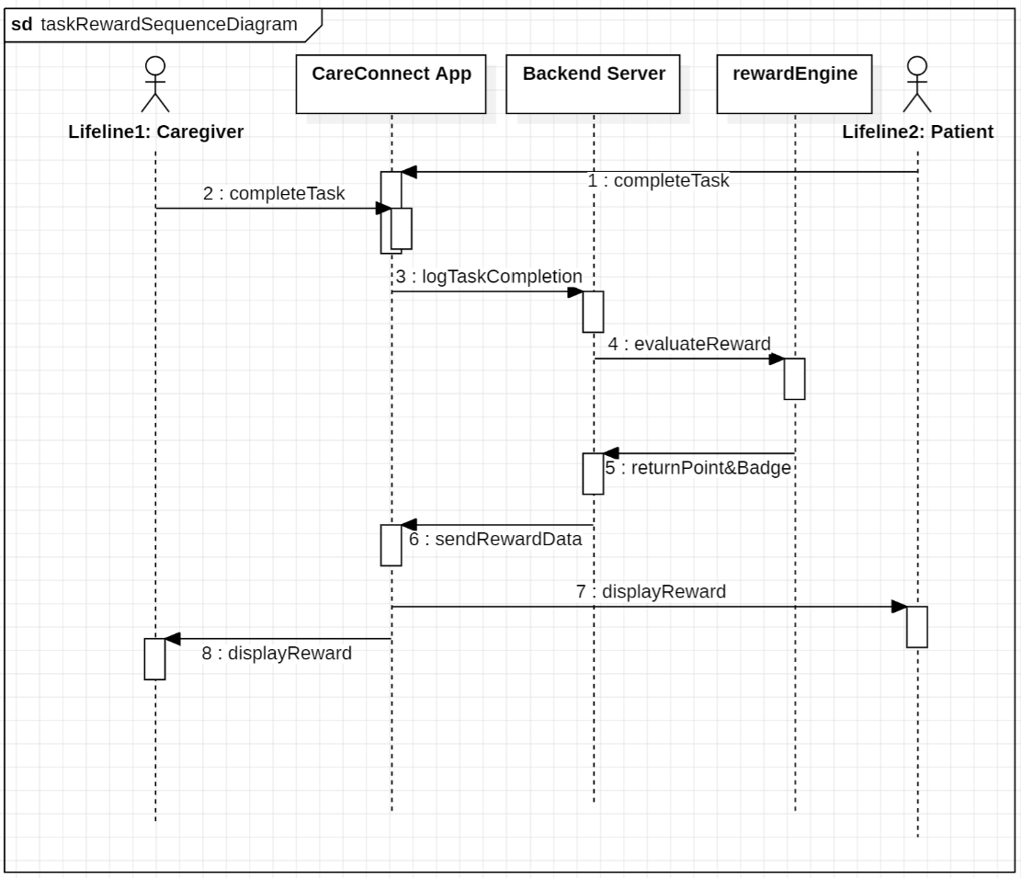

### Daily motivation messages on dashboard

#### Description

Each day, CareConnect displays a motivational message on the dashboard to uplift and inspire users. These messages promote emotional well-being and encourage continued app use

#### Stimulus/Response Sequences

* **Stimulus**: User opens the dashboard for the first time each day.  
  **Response**: The system displays a new motivational message prominently at the top of the dashboard.
* **Stimulus**: User refreshes or revisits the dashboard on the same day.  
  **Response**: The system retains and displays the same message shown earlier that day.

#### Functional Requirements

* **REQ-5.10.2.1**: The system shall display a new motivational message once per day to each user upon accessing the dashboard.
* **REQ-5.10.2.2**: The system shall select messages from a predefined list stored within the application.
* **REQ-5.10.2.3**: The system shall ensure that motivational messages are not repeated within a 14-day period.
* **REQ-5.10.2.4**: The system shall ensure that the same daily message is consistently shown throughout the day, even across multiple logins.

#### Sequence Diagram

Figure 25 depicts the daily motivation messages sequence diagram.

**Figure 25**

*Daily Motivation Messages Sequence Diagram*

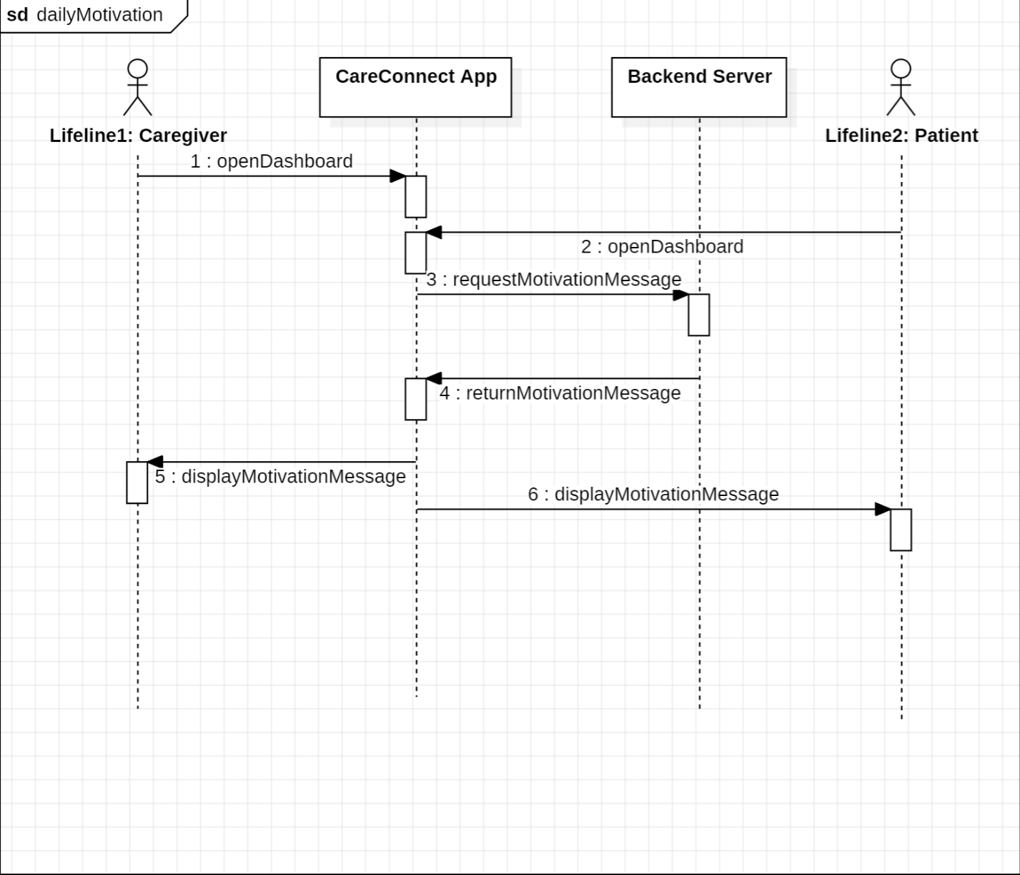

#### 5.10.3. Use Case Diagram

Figure 26 depicts the daily motivation messages use case diagram.

**Figure 26**

*Daily Motivation Messages Use Case Diagram*

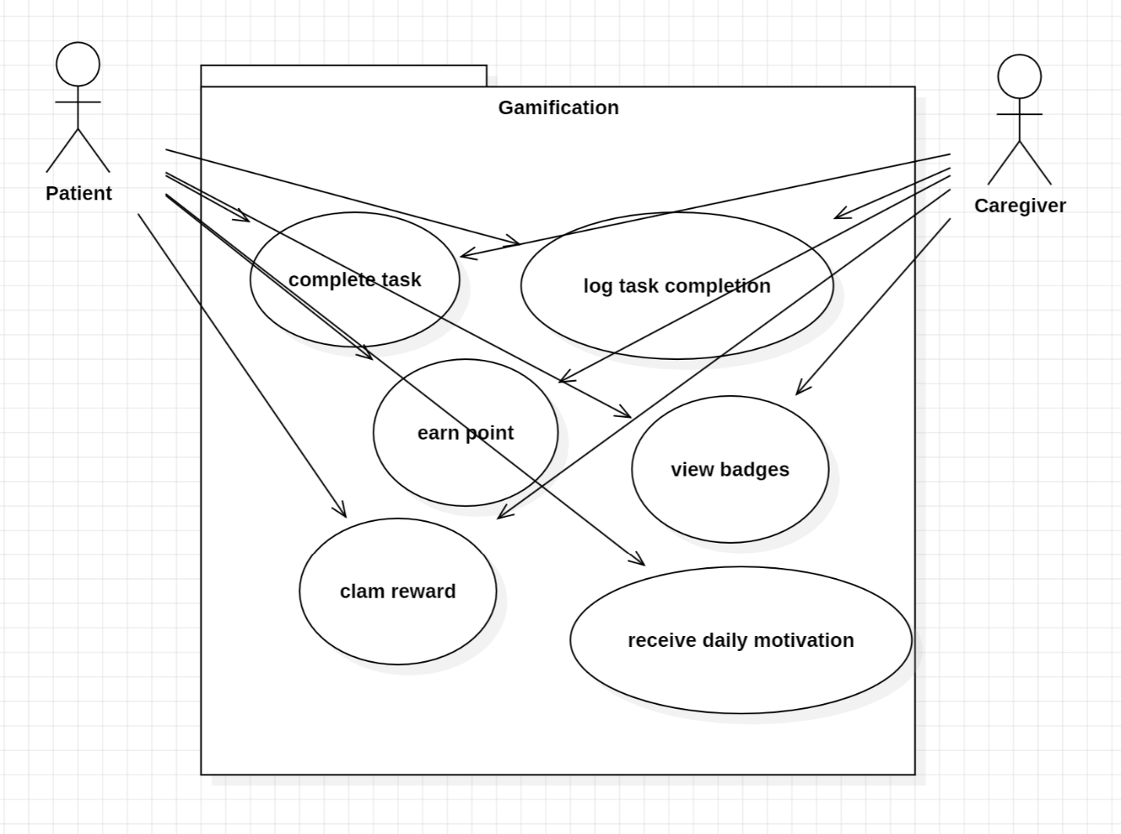

## Social Networking

### Secure In-App Messaging

#### Description

CareConnect provides a secure, HIPAA-compliant messaging feature that supports text, voice, and video messages between patients, caregivers, and authorized family members. This ensures centralized and private communication without the need to share personal phone numbers.

#### Stimus/Response Sequences

**Stimulus:** Caregiver sends a secure text message through the in-app chat.

**Response:** The system delivers the message in real-time and displays confirmation.

**Stimulus:** Patient receives a voice or video message.

**Response:** The system provides a notification and playback interface within the app.

Functional Requirements

REQ-5.11.1.1: The system shall allow users to send and receive secure text messages.

REQ-5.11.1.2: The system shall support audio and video messaging features.

REQ-5.11.1.3: The system shall implement end-to-end encryptions for all in-app communications.

REQ-5.11.1.4: The system shall not require users to expose personal contact information for communication.

#### Sequence Diagram

Figure 27 depicts the in-app messaging sequence diagram.

**Figure 27**

*In-app Messaging Sequence Diagram*

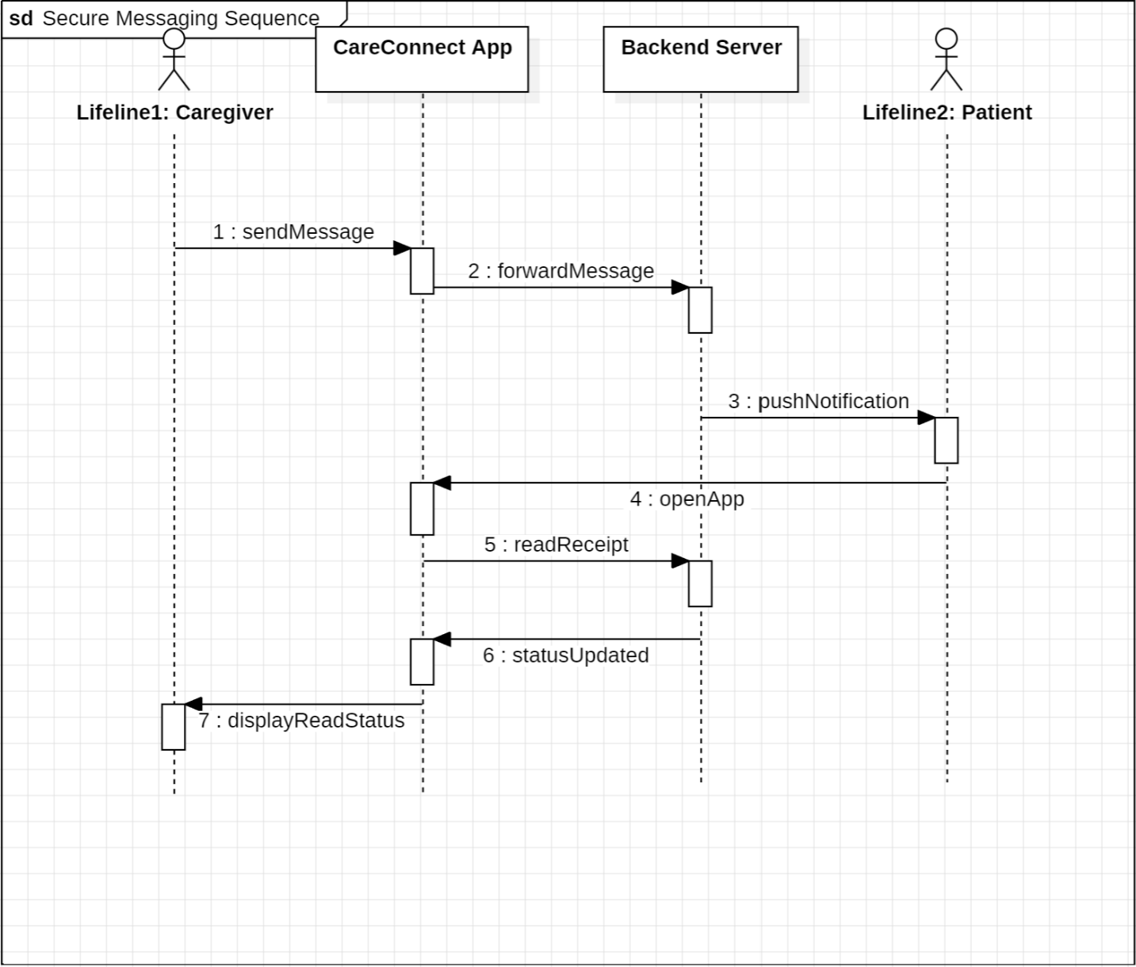

5.11.2 Family Read-Only Access

#### Description

CareConnect enables caregivers to invite family members to access selected patient data in a read-only format. This allows loved ones to stay informed without overwhelming the primary caregiver or breaching patient privacy.

Stimulus/Response Sequences

Stimulus: Caregiver sends an access invite to a family member.

Response: The system generates a time-limited invitation with role-based access.

Stimulus: Family member log-in with granted access.

Response: The system displays approved data only (e.g., meals, symptom logs)

#### Functional Requirements

#### REQ-5.11.2.1: The system shall allow caregivers to invite family members with read-only access.

#### REQ-5.11.2.2: The system shall support role-based access to control what data is viewable.

#### REQ-5.11.2.3: The system shall allow caregivers to revoke or update access permissions at any time.

Sequence Diagram

Figure 28 depicts the family read-only access sequence diagram.

**Figure 28**

*Family Read-Only Access Sequence Diagram*

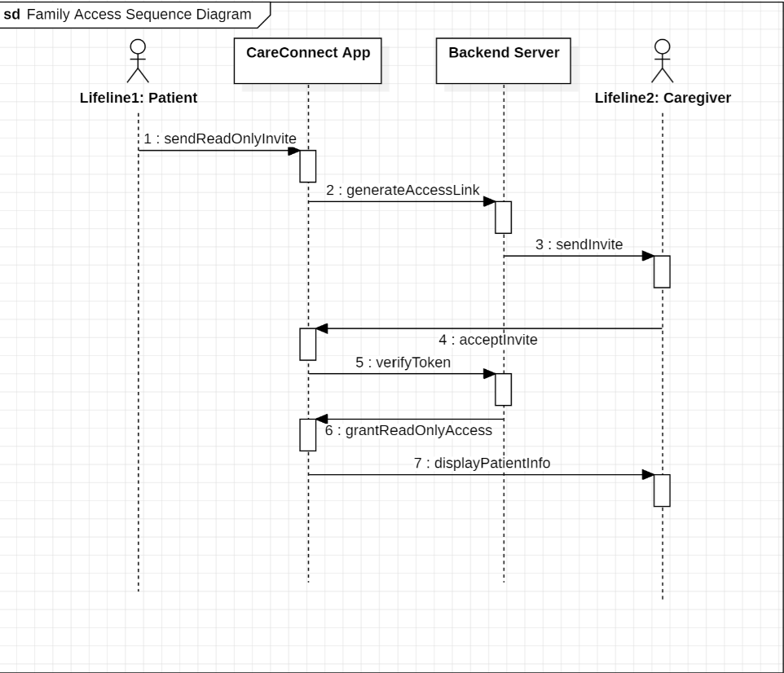

5.11.3 Shared Care Calendar

Description

The shared care calendar enables patients, caregivers, and family members to view upcoming care-related events, caregiver shifts, and appointments in one centralized interface

#### Stimulus/Response Sequences

**Stimulus:** Caregiver adds a new task or availability schedule.

**Response:** The system updates the shared calendar in real time.

**Stimulus:** Family members check the calendar.

**Response:** The system displays current caregiver availability and tasks.

Functional Requirements

REQ-5.11.3.1: The system shall provide a calendar view of caregiver availability and scheduled tasks.

REQ-5.11.3.2: The system shall update calendar events in real-time across authorized devices.

REQ-5.11.3.3: The system shall restrict calendar editing access based on user role.

#### Sequence Diagram

Figure 29 depicts the shared calendar sequence diagram.

**Figure 29**

*Shared Calendar Sequence Diagram*

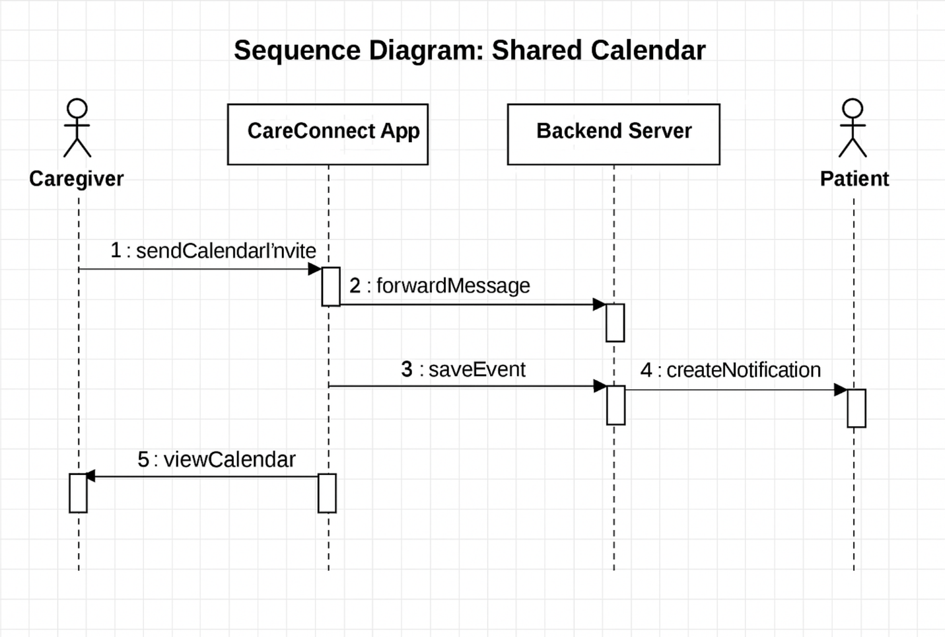

5.11.4 Emotional Check-Ins & Status Indicators

Description

This feature enables patients to express how they feel using simple emoji sliders, while caregivers can set their status (e.g., Do Not Disturb) to help coordinate interactions more effectively.

#### Stimulus/Response Sequences

**Stimulus:** Patient selects a mood emoji in the app.

**Response:** The system logs the mood and makes it viewable to the assigned caregiver.

**Stimulus:** Caregiver sets Do Not Disturb mode.

**Response:** The system queues non-urgent messages and displays their status to others.

Functional Requirements

**REQ-5.11.4.1:** The system shall allow patients to submit emotional status using emojis or slides.

**REQ-5.11.4.2:** The system shall display caregiver availability using custom status indicators.

**REQ-5.11.4.3:** The system shall queue for non-urgent messages when a caregiver is in DND mode.

#### Sequence Diagram

Figure 30 depicts the emotional check-ins and status sequence diagram.

**Figure 30**

*Emotional Check-ins and Status Sequence Diagram*

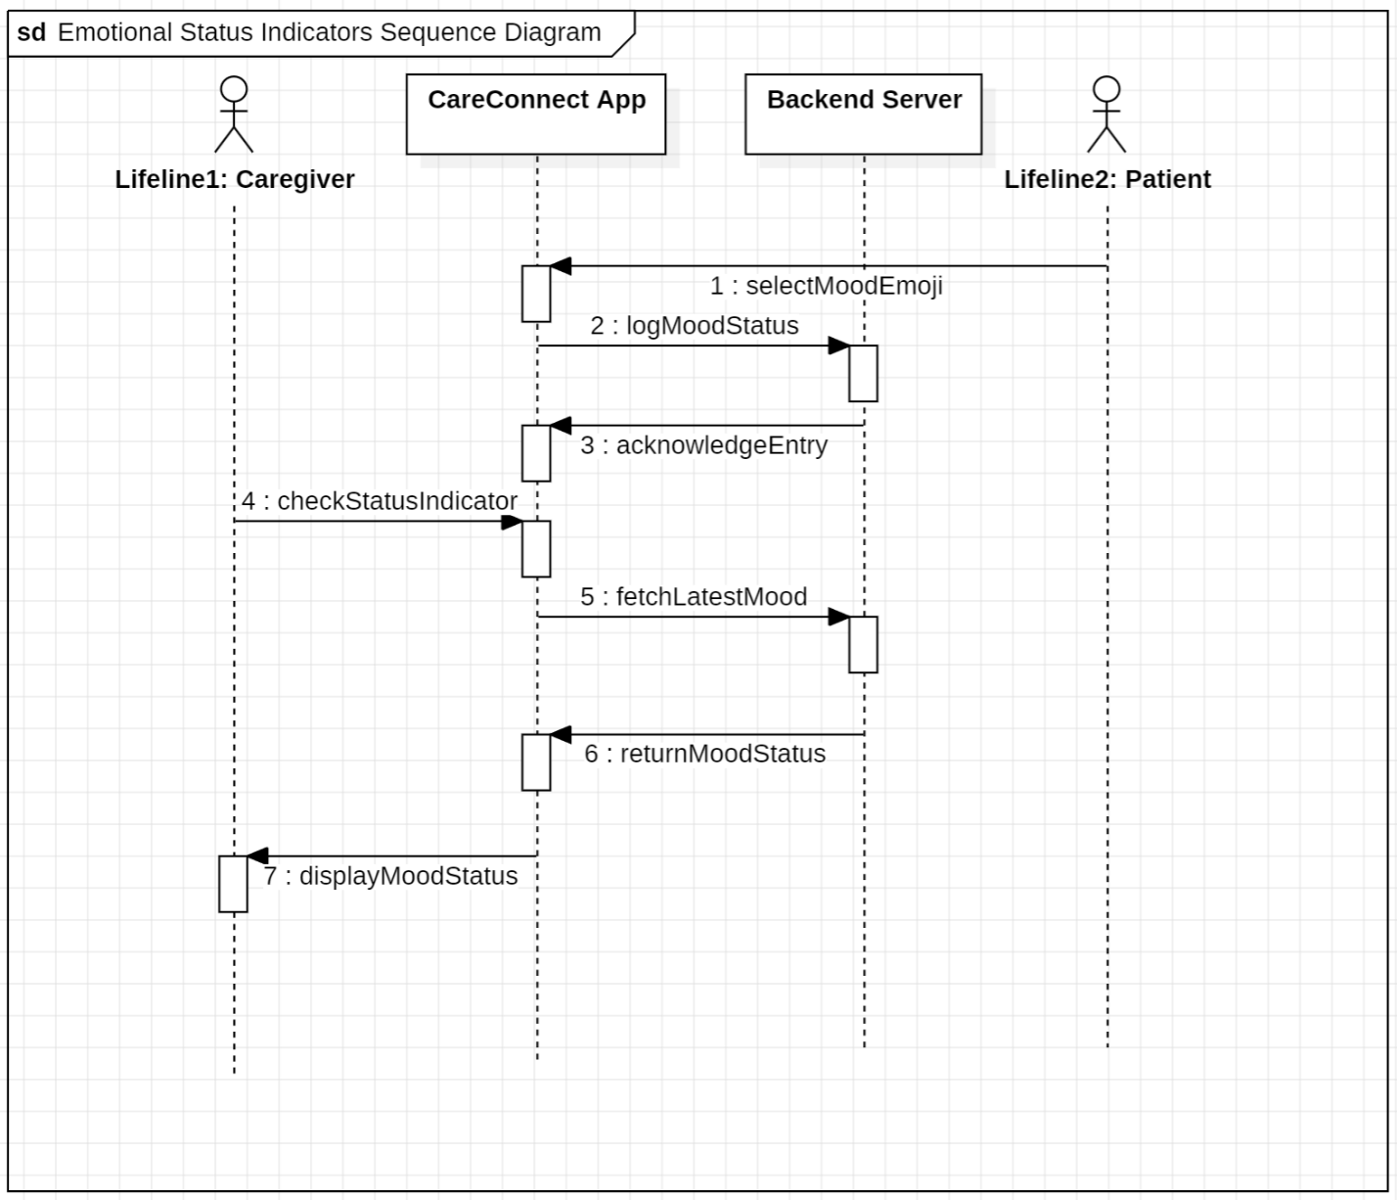

#### 5.11.5 Use Case Diagram

Figure 31 depicts the emotional check-ins and status use case diagram.

**Figure 31**

*Emotional Check-ins and Status Use Case Diagram*

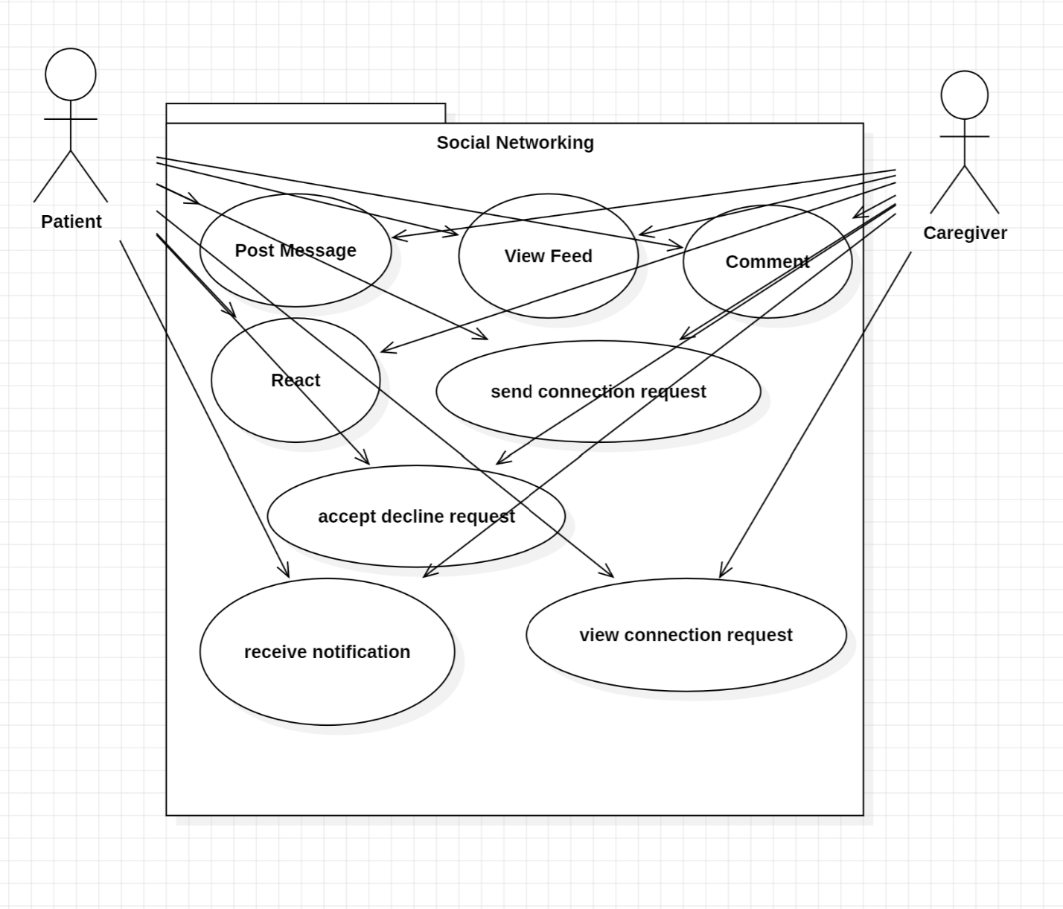

## Analytics & Reporting

### Dashboard Metrics (adherence rates, vital trends)

**FR-A1: Adherence Visualization**

* + *Description:* System shall calculate each patient’s medication and symptom check adherence rate (percentage of completed tasks) and render as a line or bar chart.
  + *Priority:* High
  + *Dependencies:* Health entries (Section 7.x), scheduling tasks.
  + *Acceptance Criteria:* Charts update when new entries arrive; can filter by 7/30/90 days.

**Stimulus/Response**

Stimulus: *Caregiver* opens the dashboard

Response: Query 7-day adherence & vital metrics aggregates and render charts

**FR-A2: Vital Trends**

* + *Description:* System shall graph time-series data for wearable metrics (e.g., heart rate, SpO₂) alongside symptom scores to show correlations. Health vitals can be synced from wearable devices (e.g., Fitbit API)
  + *Priority:* Medium
  + *Dependencies:* Device metrics (Section 7.x), health entries.
  + *Acceptance Criteria:* Two-axis charts render correctly; selectable metrics.

**Stimulus/Response**

Stimulus: *Caregiver* changes date filter to 30 days

Response: Fetch 30-day aggregates and redraw charts

### Report Exports (CSV, PDF)

**FR-A3: CSV Export**

* + *Description:* Caregiver may export raw logs (symptoms, meals, device data) for a chosen date range in CSV.
  + *Priority:* High
  + *Dependencies:* Dashboard filters, file-generation service.
  + *Acceptance Criteria:* Downloadable CSV file with headers matching column names; no PII leaks.

**Stimulus/Response**

Stimulus: Caregiver presses **Export CSV**

Response: Stream-generate CSV for selected range and initiate download

**FR-A4: PDF Summary Report**

* + *Description:* Caregiver may generate a PDF report including summary statistics, charts, and trend narratives for a selected period.
  + *Priority:* Medium
  + *Dependencies:* Chart rendering library, PDF generator.
  + *Acceptance Criteria:* PDF includes charts, tables, and metadata; printable layout.

**Stimulus/Response**

Stimulus: Caregiver presses **Generate PDF**

Response: Compile charts & stats into PDF, place signed URL in response, notify when ready

### Real-time vs. Batch Processing

**FR-A5: Live Data Feed**

* + *Description:* Dashboard shall subscribe to real-time updates via WebSocket or AWS AppSync for current-day events.
  + *Priority:* Medium
  + *Dependencies:* Notification service, front-end client.
  + *Acceptance Criteria:* New entries appear within 5 seconds of creation.

**Stimulus/Response**

Stimulus: A new symptom or wearable metric is saved for a patient linked to the caregiver.

Response:

1. Analytics service publishes an event to WebSocket/AppSync stream (< 1 s).
2. Connected dashboards receive the event and append the data point to charts (< 5 s total latency)

**FR-A6: Scheduled Aggregation Jobs**

* + *Description:* System shall run nightly batch jobs to precompute 7-, 30-, and 90-day aggregates and store in a summary table.
  + *Priority:* Medium
  + *Dependencies:* Analytics database, cron scheduler (AWS EventBridge).
  + *Acceptance Criteria:* Summary tables update by 2 AM daily; dashboard loads aggregates without delay.

**Stimulus/Response**

Stimulus: Nightly ETL scheduler (AWS EventBridge) triggers at **02:00 UTC**.

Response:

1. Batch job computes 7-/30-/90-day aggregates from raw metrics.
2. Service upserts results into summary_metrics table and logs completion (< 15 min SLA).
3. Dashboards served after 02:00 UTC use these pre-computed tables for faster load (< 1 s).

**Use Case Diagram**

U,{214f339f-25d3-466e-a92d-03c1aa5e8447}{128},3.125,3.125

*Figure x. Caregiver interactions with analytics features.*

1. **View Dashboard Metrics:** Caregiver accesses charts of adherence and vitals.
2. **Filter Time Window:** Caregiver chooses the period of interest (7/30/90 days).
3. **Export CSV Report:** Raw data is downloaded as CSV.
4. **Generate PDF Summary:** System compiles statistics and charts into a printable PDF.
5. **Subscribe to Live Updates:** Dashboard updates in real time via push feed.
6. Configure Batch Jobs: Backend schedules nightly aggregation for performance optimization.

**Real-Time Dashboard Metrics (Live Feed)**

Figure 32 shows the real-time dashboard metrics (live feed) sequence diagram.

**Figure 32**

*Real-Time Dashboard Metrics Sequence Diagram*

All components communicate via API Gateway and ECS-hosted Spring Boot services

1. 5.12‑1*Open Dashboard* – Caregiver launches analytics screen.
2. Client fetches 7-day aggregates via REST.
3. Analytics service queries MetricsDB, returns JSON; charts render.
4. Client upgrades to WebSocket for live events; service streams updates that appear within 5 seconds.

**Generate PDF/CSV Summary Report Sequence**

Figure 33 depicts the generate PDF/CSV summary report sequence diagram.

**Figure 32**

*Generate PDF/CSV summary report sequence diagram*

5.12‑2

1. Caregiver requests a 30-day PDF summary.
2. ReportService gathers raw metrics, calls an internal PDFService to format charts/tables.
3. A signed URL is returned; caregiver downloads the report.

# Nonfunctional Requirements

## Data Encryption (in-transit, at rest)

To ensure the protection of sensitive personal and health data, CareConnect implements robust encryption protocols for all stored and transmitted information. This is a **High Priority** requirement due to its role in ensuring HIPAA and GDPR compliance. Sensitive data encryption is applied both in transit (TLS 1.3) and at rest (AES-256), ensuring that user data remains secure and protected from unauthorized access.

## Regulatory Compliance (HIPAA, GDPR)

CareConnect is legally obligated to follow regulatory standards concerning the handling of Protected Health Information (PHI) and personal data. These compliance features are **High Priority** and impact nearly every subsystem of the application.

## Accessibility

CareConnect shall ensure accessibility features are incorporated in the application. Such accessibility features shall be followed by the WCAG 2.1 Level AA accessibility standards. These standards include (but are not limited to): color contrast, voice-activated command support, alternative text for images, and screen reader compatibility (Gies College of Business, n.d.). Priority = High.

## Offline Mode

CareConnect shall provide an offline mode in the event that patients and caregivers do not have internet access. This offline mode shall have limited capabilities due to the dependency on various functions for an internet connection. Priority = High.

## UI/UX Notes

“The CareConnect interface shall prioritize simplicity, clarity, and consistency to accommodate a wide range of user familiarity with technology. The design will follow mobile-first, responsive principles and maintain consistent iconography, navigation patterns, and color schemes” (OpenAI, 2025). Priority = High.

## Backup & Disaster Recovery

CareConnect shall have a process for data back-up and recovery in the event of a disaster scenario while using the application. In this case, “daily incremental backups and weekly full backups will be stored securely using AWS S3 with cross-region replication. In the event of a system failure or security breach, the application shall be able to restore data within 24 hours and maintain an uptime of 99.9% or higher” (OpenAI, 2025). Priority = High.

## Performance & Scalability Targets

CareConnect shall maintain performance and scalability targets while the app is in operation. Priority = High. The performance and scalability targets are as follows:

* Performance: <200 ms p99 API; <2 s dashboards; <150 ms call latency
* Scalability: Auto-scaling ECS/EKS; stateless services; S3/CDN for media
* Support a growing user base—from pilots to enterprise-scale—through scalable architecture.
* Ensure system availability during peak usage
* Enable proactive identification of performance issues before they impact users.

# Future Scenario/Functional Requirements

The following items shall be addressed and implemented by future cohorts:

## 7.1 Multilingual Support

This function shall add multilingual support for the CareConnect application.

## 7.2 Health Simulator Integration with DeepTrain

This function shall utilize DeepTrain’s training design simulator for health topics to allow the Caregiver to create trainings for users on topics regarding healthcare.

## 7.3 Home Monitoring Integration

This function shall allow the integration of a third-party home monitoring system to allow for visual and auditory monitoring inside a patient’s home.

## 7.4 Smart Home Integration

This function shall allow the integration of a third-party smart home device to allow for additional task completion with the provided functionalities of the third-party device.

## 7.5 Wearables and Health Metrics Enhancement

Add more functionality to allow connectivity to other medical devices or metrics that are not available via the provided ecosystem APIs (Google/Apple Health). Most devices such as blood pressure, glucose and pulse-oximeters have Bluetooth functionality that may be leveraged to obtain metrics directly from the device. Additionally, several companies offer API access to their devices, while not all of them are free, we may be able to leverage other existing health related applications and systems who already have this access that can be shared with care connect.

## 7.6 Patient Linking

Further work is required to link patient and caregiver accounts through the use of a QR code or a one-tap share to automatically connect accounts without the use of email confirmation from the patient.

## 7.7 Reminder & Alert System

This function shall send reminders and alert notifications to patients from their connected caregivers to complete tasks.

## 7.8 Virtual Check-In Rounds

This function shall allow caregivers to create a set of questions for the patient to complete in a periodic manner set by the caregiver.

## 7. 9 Voice-Activated Commands

This function shall allow patients and caregivers to complete actions in CareConnect through the use of voice-activated commands.

## 7. 10 Telehealth Bridge

This function shall allow patients to utilize CareConnect for joining appointments with healthcare professionals.

## 7. 11 Caregiver Shift Scheduling

This function shall allow caregivers to have active and non-active hours when caring for patients and allow patients to view which caregiver is available for communications.

## 7. 12 Meal & Nutrition Tracking

This function shall allow patients to track what was eaten during each meal and the nutritional intake of each meal for both patient and caregiver records.

## 7. 13 AI Mood Detection/Facial Tracking

Further work is required to capture the moods that are detected during calls and quantify the information for caregiver analysis. Currently, the primary interest is to produce the measurements as a radar chart. In addition, emotion detection should only be recorded after a determined amount of time has passed with the patient maintaining the same emotion (since facial expressions can change in a rapid pace over time).

## 7. 14 Gamification

Further work is required to have reoccurring achievements for patients and caregivers. There should also be separate types of achievements between patients and caregivers.

## 7. 15 Medication Management

Further work is required to allow for voice dictation of adding, editing, and removing medications. In addition, there is an interest in the medication list being accessible by emergency services in the event of a medical emergency by the patient.